Self-Reconciling Data Pipeline POC
Build runbook: what was done, why, and how to repeat it
Covers: Phase 0 (Foundations), Phase 1 (Ingest and archive), Phase 2 (dbt models, reconciliation checks, lab value checks, KMS value-level reconciliation, dbt in Airflow) — Phase 2 exit gate passed
GCP project: reconcile-poc-29056 · region asia-south1 (Mumbai)
Operator account: rathiashish458@gmail.com (GCP free trial)
Repository: github.com/rathibhavna257-stack/Self-Reconciling-Data-Pipeline (private)
Author: Bhavna Rathi
Version: 1.2 · 22 Oct 2026

Tip: This is a living document. Each phase section explains what the step does, why it is needed, an example from our own run, the exact commands and queries, and screenshots of the result. New phases are added in the same format.

Contents
§ | Section
1 | What this POC is about — the story in one example, architecture
2 | Environment and key terms
3 | Laptop setup (Windows, no admin rights) and the daily routine
4 | Phase 0 — Foundations (Terraform, console, CI)
5 | Phase 1 — Ingest, receipts and raw archive
6 | Phase 2 — dbt models and reconciliation checks
7 | Next — Phase 3: the publication gate
8 | Query library
9 | Troubleshooting
10 | Change log

1. What this POC is about
Today our pipelines prove that they ran, not that the data is right. A nightly load can finish "green" while hundreds of records are missing, and the first person to notice is a ward manager. The POC wraps the pipeline in a control loop: detect → hold → decide → fix → verify, proven on synthetic hospital data on Google Cloud.
Step | What happens | Phase
Receipt | Every load writes a receipt (row count, unique IDs, empty amounts, ₹ total) from the same database snapshot as its rows | 1 ✅
Detect | dbt checks each day of data against its receipt | 2 (core ✅)
Hold | A day that fails is not published; reports keep the last good day, marked delayed | 3
Decide and fix | A deterministic engine picks one safe fix (e.g. replay a missing hour) and re-checks | 4
Advise | AI agents explain unknown failures; data owners approve risky fixes | 5
Group | A source outage becomes one incident, not twenty | 6

Why: The single promise to report users: you may see slightly old numbers, but never wrong ones.

The story in one example (13 October)
- 01:00 IST: Airflow loads 13 Oct encounters. The extract counts the source in the same snapshot and writes a receipt: 10,012 rows, 10,012 IDs.
- A network blip drops the 02:00–03:00 hour. Only 9,895 rows reach BigQuery. Airflow still shows green.
- 02:00: dbt rebuilds the clean table and compares it with the receipt: 10,012 ≠ 9,895 → the reconciliation test fails and names the day and batch.
- The day is reloaded cleanly and dbt re-checks: 10,012 = 10,012 → pass. (Phase 4 will do this automatically.)
- With Phase 3, reports would have kept showing 12 Oct, marked "delayed", until 13 Oct passed.

Architecture at a glance
Sources (Postgres) Google Cloud (asia-south1)
EHR / LIS / Billing
│ Airflow ingest ──► Cloud Storage archive (write-once) [P1]
│ + receipt ──► BigQuery raw + ops.control_totals [P1]
│ dbt build + reconciliation tests [P2]
▼
BigQuery audit ──gate──► analytics [P3]
│ failures
▼
Pub/Sub ► decision engine ► executor [P4]
Cloud SQL ops state · Cloud Run console [P0+]

2. Environment and key terms

What runs where
Component | Where | Notes
GCP project | reconcile-poc-29056, asia-south1 | Free trial (90 days, $300 credit)
Terraform | Run from the Windows laptop only | State file infra/terraform.tfstate lives there
Airflow 3.3.2 + source Postgres | Docker Desktop on the laptop | http://localhost:8080; Postgres on port 5433
Console + API | Cloud Run reconcile-console | Private; open with make console → http://localhost:8081
dbt 1.12 (core + bigquery) | Laptop venv, dbt/reconcile | Builds into audit as sa-dbt
Code | GitHub, branch main | CI: lint, tests, policy, dbt parse, Terraform validate, DAG import, console build

The BigQuery datasets
Dataset | Holds | Who can write
raw | Exactly what came from the source, one partition per business date | ingest only
audit | dbt staging tables and report tables, built and tested first | dbt, executor
analytics | Verified data only — what reports read (Phase 3) | publish only
quarantine | Rows moved out of marts | dbt, executor
ops | control_totals (receipts), batches (load log), source_health | ingest, engine
evidence_restricted | Keys and field names of value mismatches, never values | value-recon only

Key terms
Term | Meaning
Business date | The hospital (India, IST) day a record belongs to. Systems store UTC; the extract cuts on the IST day.
Receipt / control totals | Counts written by the extract from the same snapshot as its rows: row count, distinct keys, empty amounts, ₹ total. Stored in ops.control_totals.
Batch | One load of one table for one business date, e.g. b-20261013-encounters-04. Each re-load gets a new batch ID.
Archive | The untouched Parquet file of every load in Cloud Storage. Cannot be overwritten or deleted for 7 days.
Idempotent | Running a load once or ten times gives the same result (the day is replaced, never added twice).
Staging (stg_*) | dbt clean tables in audit: one row per ID per day, duplicates removed.
Mart (dim_*, fct_*) | Report-ready tables built from staging.
Look-back | Each dbt run rebuilds the chosen day and the 2 days before it, to pick up late changes such as reversed claims.
Injector | A switch that breaks a load on purpose (e.g. drop_hour) to prove the checks catch it.
Exit gate | The checks that must pass before a phase is called done.

3. Laptop setup (Windows, no admin rights)
The project was built from a company Windows laptop without admin rights. Everything installs per-user with Scoop, and all project commands run in Git Bash (inside Cursor or VS Code: Terminal → Select Default Profile → Git Bash).
Why: The project uses make, bash scripts and $RANDOM, which do not run in PowerShell. Git Bash gives a bash shell without installing Linux.

3.1 Install the tools (PowerShell, once)
Set-ExecutionPolicy -ExecutionPolicy RemoteSigned -Scope CurrentUser
Invoke-RestMethod -Uri https://get.scoop.sh | Invoke-Expression
scoop install git fnm terraform make
# company network blocks Scoop "buckets", so install these two from their manifest URLs:
scoop install https://raw.githubusercontent.com/ScoopInstaller/Versions/master/bucket/python312.json
scoop install https://raw.githubusercontent.com/ScoopInstaller/Extras/master/bucket/gcloud.json

Docker Desktop was already installed; it uses the WSL 2 engine (no Ubuntu distro needed).
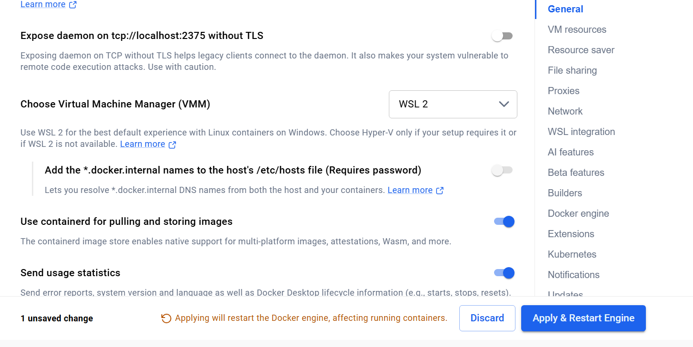
Docker Desktop → Settings → General: Virtual Machine Manager = WSL 2

3.2 Git Bash setup (once)
bind 'set enable-bracketed-paste off'
echo "bind 'set enable-bracketed-paste off'" >> ~/.bashrc # stops ^[[200~ on paste
sed -i '1i export PATH="$HOME/scoop/shims:$PATH"' ~/.bashrc # Scoop tools visible in Git Bash
echo 'eval "$(fnm env --use-on-cd --shell bash)"' >> ~/.bashrc
source ~/.bashrc
fnm install 22 && fnm default 22
git config --global core.autocrlf input # BEFORE cloning: keep Unix line endings

Watch: If core.autocrlf is not set before cloning, shell scripts get Windows line endings and fail inside Docker with bad interpreter or \r: command not found. Check with git ls-files --eol | grep "w/crlf" — it must print nothing.

3.3 Clone and create the Python environment
cd /c/Users/Bhavna/Desktop/Pipeline_reconcile
git clone https://github.com/rathibhavna257-stack/Self-Reconciling-Data-Pipeline.git
cd Self-Reconciling-Data-Pipeline
python312 -m venv .venv # another Python (3.14) is first on PATH, so name 3.12 explicitly
source .venv/Scripts/activate
cp .venv/Scripts/python.exe .venv/Scripts/python3.exe # the Makefile calls python3
python3 -m pip install --upgrade pip
make dev-setup # Python packages, dbt, and npm ci for the console

3.4 Settings added to the venv activate script (once)
These run automatically every time you activate the venv, and only affect this project:
echo 'unset GOOGLE_APPLICATION_CREDENTIALS' >> .venv/Scripts/activate # another project's key was set
echo 'export TMPDIR="$(cygpath -m /tmp)"' >> .venv/Scripts/activate # Windows-readable temp path
echo 'export GCLOUD_CONFIG_DIR="$(cygpath -m "$APPDATA")/gcloud"' >> .venv/Scripts/activate # Airflow's Google login

3.5 Every working session
- Start Docker Desktop and wait for "Engine running".
- Open Git Bash in the project folder: cd /c/Users/Bhavna/Desktop/Pipeline_reconcile/Self-Reconciling-Data-Pipeline
- Activate: source .venv/Scripts/activate
- Check login: gcloud config get-value project → reconcile-poc-29056; gcloud auth application-default print-access-token > /dev/null && echo ADC ok
- If Cloud SQL was paused: gcloud sql instances patch reconcile-state --activation-policy=ALWAYS
- git pull (use PowerShell if Git Bash cannot reach GitHub), then make up (Airflow at http://localhost:8080).
- For dbt work, open a second terminal: activate, then set -a; source .env; set +a and cd dbt/reconcile.
- End of day: pause the ingest DAGs in Airflow, make down, optionally pause Cloud SQL (--activation-policy=NEVER).

Run from… | Commands
Project root (…/Self-Reconciling-Data-Pipeline) | make …, git …, docker compose …, terraform (via make)
dbt/reconcile (with .env loaded) | dbt build, dbt debug, dbt test
PowerShell (fallback) | git push when Git Bash hits the company certificate check

4. Phase 0 — Foundations
Status: built and deployed 20 Oct 2026 · Exit gate: 3 of 4 passed (destroy + rebuild proof deferred until archive retention expires, about 28 Oct).

What it does
Builds an empty, secured cloud platform with Terraform (cloud setup written as code), plus a synthetic data generator, the local Airflow, and the monitoring console.
Why: If identities, networking and datasets are improvised later, safety rules like "only the publish job can write analytics" become promises instead of facts. Building them first, as code, makes every later phase inherit them, and one command can rebuild the same environment.

Example: Terraform creates sa-ingest with write access to raw only. In Phase 1 the verify check G4 tries to write analytics as ingest and Google refuses: Permission bigquery.tables.create denied.

4.1 Create the project and log in
gcloud auth login # choose the free-trial Gmail account
PROJECT=reconcile-poc-$RANDOM # → reconcile-poc-29056
gcloud projects create $PROJECT --name="Reconcile POC"
gcloud billing accounts list # → 016E17-7C6FB1-69E593, OPEN True
gcloud billing projects link $PROJECT --billing-account=016E17-7C6FB1-69E593
gcloud config set project $PROJECT
echo "export PROJECT=$PROJECT" >> ~/.bashrc
gcloud auth application-default login # login used by Terraform, Airflow and dbt
gcloud auth application-default set-quota-project $PROJECT

4.2 Build the platform with Terraform
# new projects: switch on the APIs Terraform itself needs, then wait 2 minutes
gcloud services enable cloudresourcemanager.googleapis.com iam.googleapis.com \
serviceusage.googleapis.com iamcredentials.googleapis.com --project=reconcile-poc-29056

cp infra/terraform.tfvars.example infra/terraform.tfvars
# project_id = "reconcile-poc-29056"
# operator_email = "rathiashish458@gmail.com"
# lock_archive_retention = false (Bucket Lock is irreversible)
make tf-init
make tf-plan # → Plan: 119 to add, 0 to change, 0 to destroy
make tf-apply # Cloud SQL takes ~12 minutes
make env # writes .env from the Terraform outputs

Resource | Purpose
6 BigQuery datasets + ops tables | raw, audit, analytics, quarantine, ops, evidence_restricted; ops.control_totals, ops.batches, ops.source_health
Archive bucket | reconcile-poc-29056-reconcile-raw-archive, 7-day retention, not locked
Cloud SQL | reconcile-state, Postgres 16, private IP 10.40.32.3 only
Pub/Sub | Topics run-complete, engine-requests, notifications, each with a dead-letter queue
9 service accounts | ingest, dbt, valuerecon, publish, engine, executor, agents, api, build
Network, registry, secrets | VPC + private service access, Artifact Registry, Secret Manager (DB password)

4.3 Local runtime and synthetic data
make up # Postgres "hospital" + Airflow, http://localhost:8080
make generate DATE=2026-10-13 DAYS=3 # DATE is the LAST day: generates 11, 12, 13 Oct
make status # lists generated dates and row counts

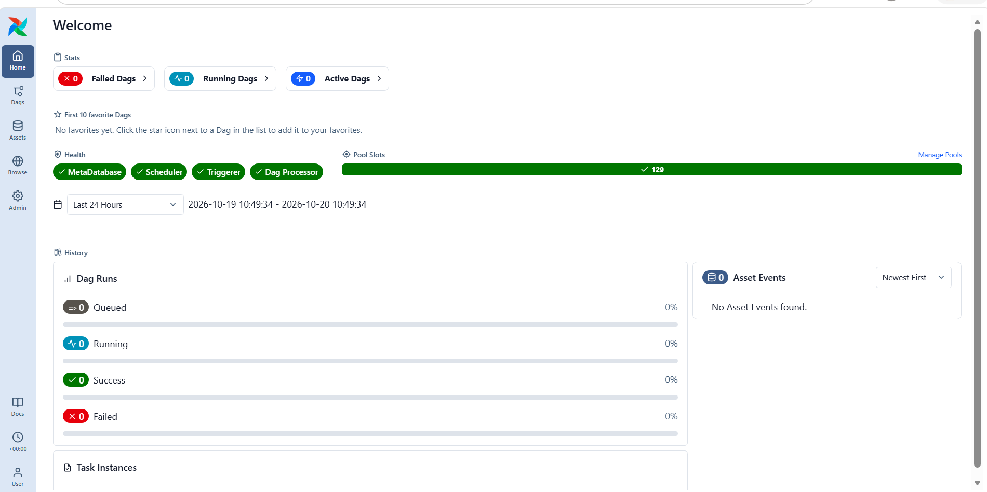
Airflow home: MetaDatabase, Scheduler, Triggerer and Dag Processor all healthy

4.4 Deploy and open the console
make deploy-console # builds on Cloud Build, deploys to Cloud Run
curl --ssl-no-revoke -H "Authorization: Bearer $(gcloud auth print-identity-token)" \
https://reconcile-console-1013751981817.asia-south1.run.app/api/health
# → {"status":"ok","checks":{"bigquery":{"ok":true},"cloud_sql":{"ok":true,"detail":"PostgreSQL 16.15"}}}
make console # proxy → http://localhost:8081 (Ctrl+C to stop)

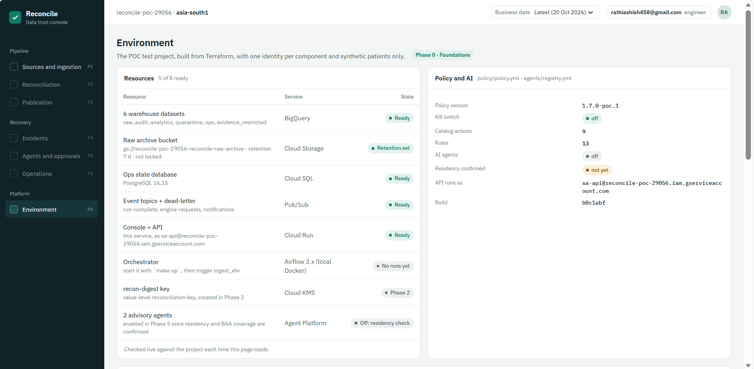
Console → Environment: 5 of 8 resources ready (the other 3 belong to Phases 1, 2 and 5); kill switch off; agents off
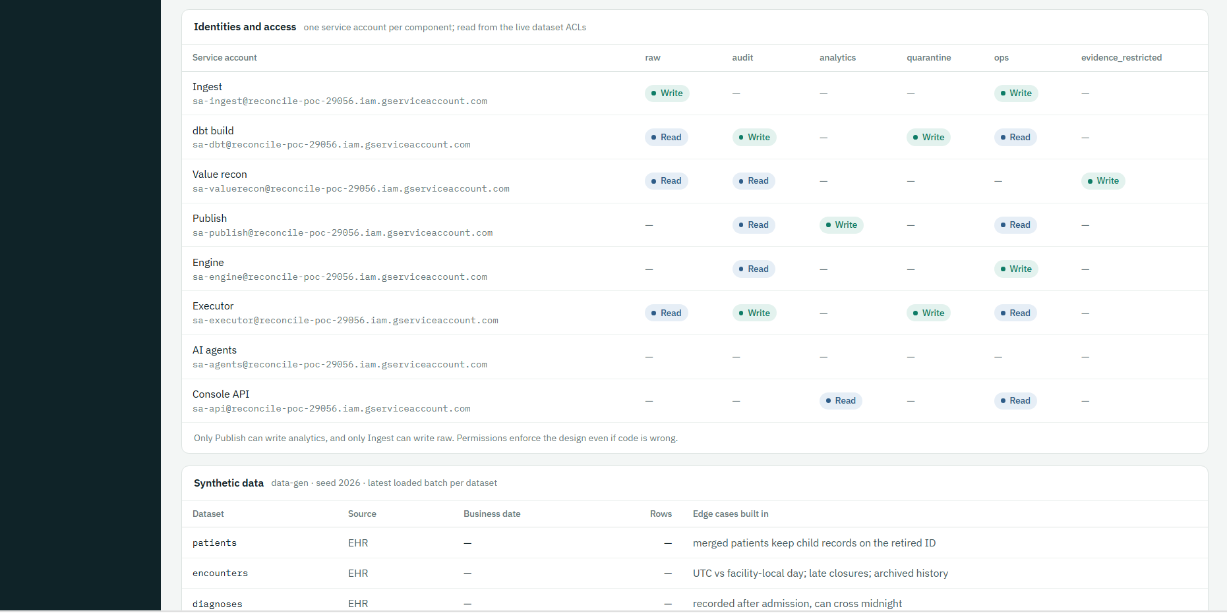
Identity matrix read from live permissions: only Ingest writes raw, only Publish writes analytics, AI agents have no data access
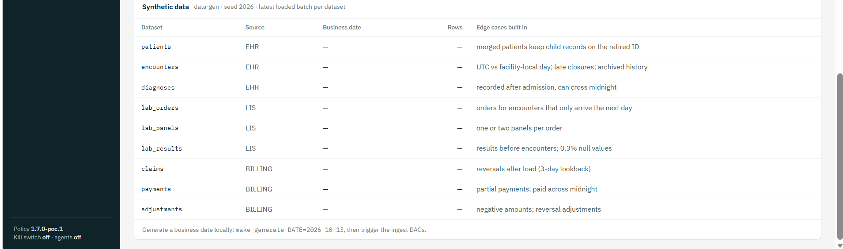
Synthetic data and the edge cases built in on purpose (empty until Phase 1 loads it)
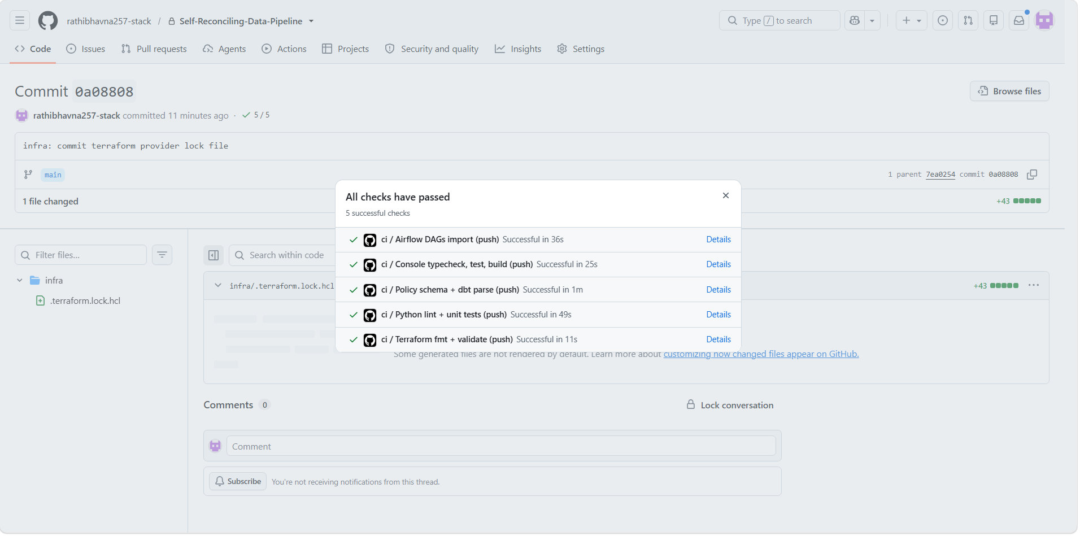
GitHub Actions: all 5 CI checks passed

Phase 0 exit gate
Check | Result
Terraform builds the environment from scratch (destroy + apply) | Apply ✅ · rebuild proof after ~28 Oct
Generator loads a business date (make status) | ✅ 11–13 Oct
Console on Cloud Run, /api/health = ok | ✅
CI green on GitHub | ✅ commit 0a08808

Issues met in Phase 0 and their fixes
Problem | Fix
tf-apply: Cloud Resource Manager API "has not been used… or it is disabled" | Enable the base APIs with gcloud services enable … (4.2), wait 2 min, re-run
ADC login warned GOOGLE_APPLICATION_CREDENTIALS is set | Unset it in the venv activate script (3.4)
deploy-console: --env-vars-file: File [/tmp/…] does not exist | scripts/deploy_console.sh converts the temp path with cygpath -m (commit 7ea0254; no effect on Mac/Linux)
CRYPT_E_REVOCATION_OFFLINE from git / curl | Company network blocks certificate-revocation checks: push from PowerShell; curl --ssl-no-revoke
make console asks for cloud-run-proxy, then "binary not installed" | Accept the install, run make console again

5. Phase 1 — Ingest, receipts and raw archive
Status: ✅ exit gate passed 21 Oct 2026 · loaded business dates 11–14 Oct · CI green on commit 3e37dac.

What it does
Moves each day of hospital data into BigQuery safely. For every table and day, the Airflow DAGs ingest_ehr, ingest_lis and ingest_billing run five steps:
Step | What happens | Why
Probe | Check the source is reachable; write ops.source_health | Never extract from a broken source
Extract | Read the rows and the totals in one read-only, repeatable-read transaction | Receipt and rows describe the same moment
Archive | Write a Parquet file + manifest (with SHA-256) to the write-once bucket | Untouched original that can be replayed
Load | One BigQuery transaction: delete the day, insert the batch, write the receipt, log the batch | Idempotent; a receipt exists if and only if the rows do
Announce | Publish run-complete to Pub/Sub | The Phase 4 engine starts from this event

Why: Phase 2 needs a trustworthy receipt to check against; Phase 4 needs an untouched copy to replay; and retries must never double the data.

Example: 13 Oct encounters: 10,012 rows land in raw.encounters with batch b-20261013-encounters-04; the receipt row in ops.control_totals says row_count 10,012, distinct_keys 10,012; the file sits at gs://…-raw-archive/raw/encounters/load_date=2026-10-13/…parquet.

5.1 Give Airflow your Google login (Windows fix)
Airflow runs in Docker and reads the Google login from a mounted folder. The compose file mounted the Mac location, so on Windows the folder inside the container was empty and every task would fail.
# docker-compose.yml line 52 (commit 3e37dac):
- ${GCLOUD_CONFIG_DIR:-${HOME}/.config/gcloud}:/home/airflow/.config/gcloud:ro
# GCLOUD_CONFIG_DIR is set by the venv activate script (3.4); Mac falls back to ~/.config/gcloud
make down && make up
docker compose exec airflow ls -la /home/airflow/.config/gcloud/ # must list application_default_credentials.json

5.2 Load a day
make trigger DATE=2026-10-13 # triggers all three ingest DAGs (and UNPAUSES them)
# wait until all three runs are green in Airflow, then:
make verify DATE=2026-10-13 # exit-gate checks G1–G5

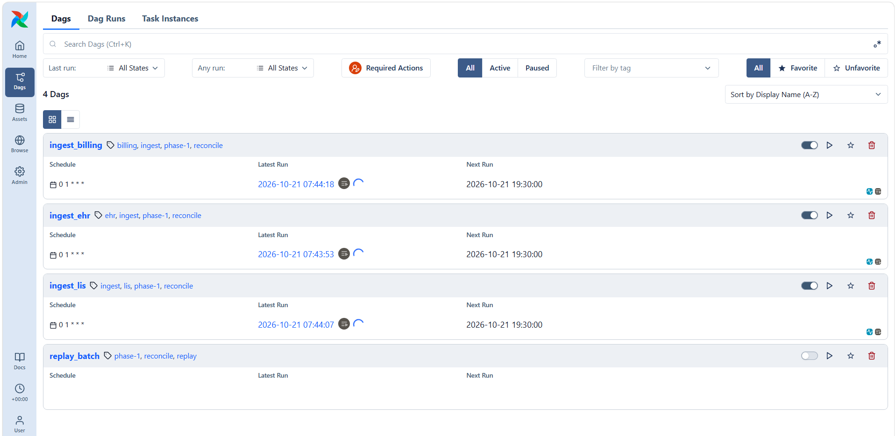
The three ingest DAGs triggered for 13 Oct (spinners = running)
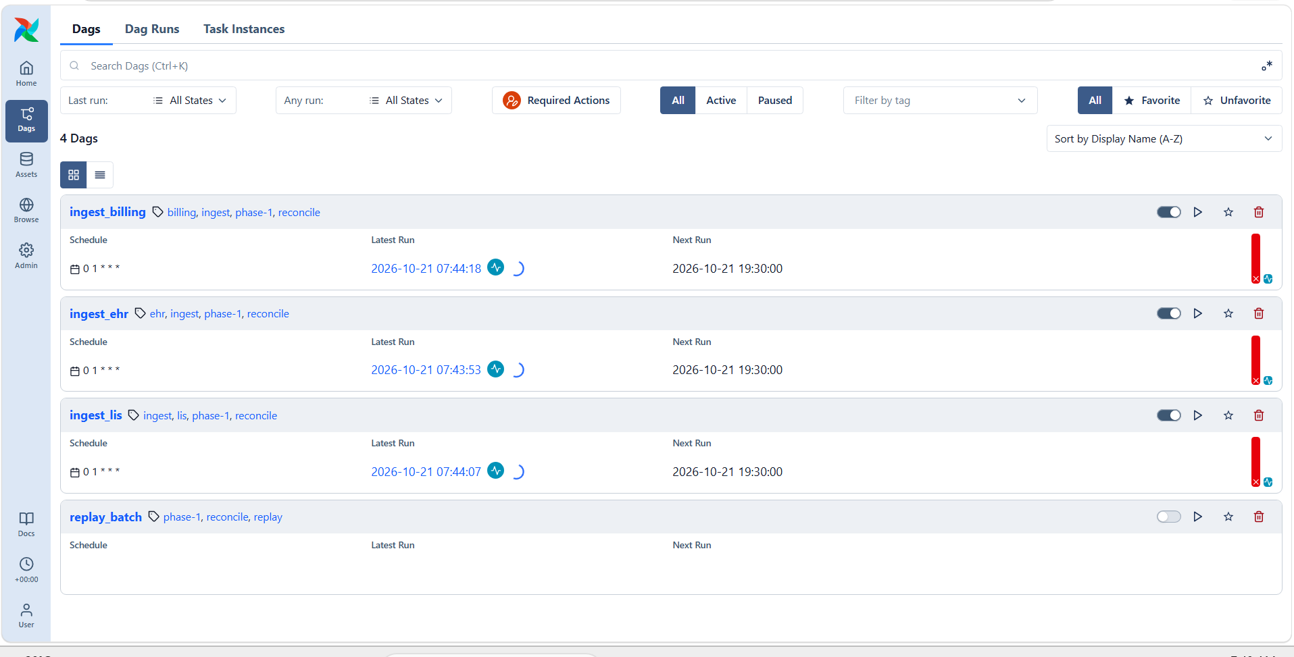
First attempt: runs failing (red) — a bug in the BigQuery load code, fixed below
Watch: Bug found and fixed: every load failed with 400 Cannot specify both decimal target types and schema. In ingest/reconcile_ingest/warehouse.py the load set both schema= and decimal_target_types=; the explicit schema already declares NUMERIC, so line 131 (decimal_target_types=[…]) was removed. Commit 3e37dac.

5.3 The exit-gate output
G1 PASS Exactly one control-totals row per batch 9 datasets loaded; 0 batches with != 1 totals row; 0 missing
G2 PASS Re-running lab_orders gives identical counts run1=5205 run2=5205 raw=5205 distinct_row_ids=5205 batches_in_partition=1
G3 PASS Archived file replays into raw replayed b-20261013-lab_orders-08: 5205 rows; raw now 5205
G4 PASS Ingest cannot write analytics denied: Permission bigquery.tables.create denied on dataset analytics
G5 PASS Archive objects cannot be overwritten/deleted overwrite denied (412); delete denied (403)

Check | Proves | Why it matters
G1 | Each load writes exactly one receipt | A missing or doubled receipt would make reconciliation meaningless
G2 | Re-running a day gives identical counts | Retries can never double the data
G3 | An archived file replays into raw | Any day can be rebuilt without asking the source again
G4 | Ingest is denied write access to analytics | Permissions enforce the design even if code is wrong
G5 | Archive files cannot be overwritten or deleted | The original stays trustworthy

Watch: Run make verify only after all three DAG runs are green. The first run showed "2 datasets loaded" because it ran while loads were still in progress. Load one date at a time so loads do not collide.

5.4 What you see in Google Cloud
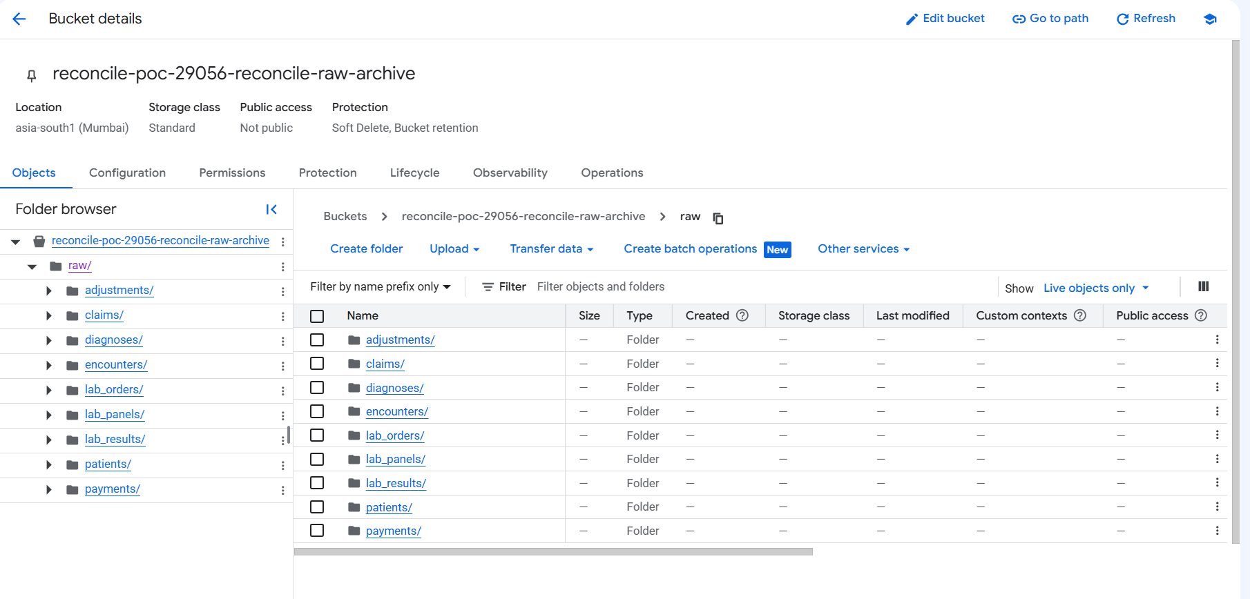
Archive bucket: one folder per table; inside, one folder per load date with the Parquet files
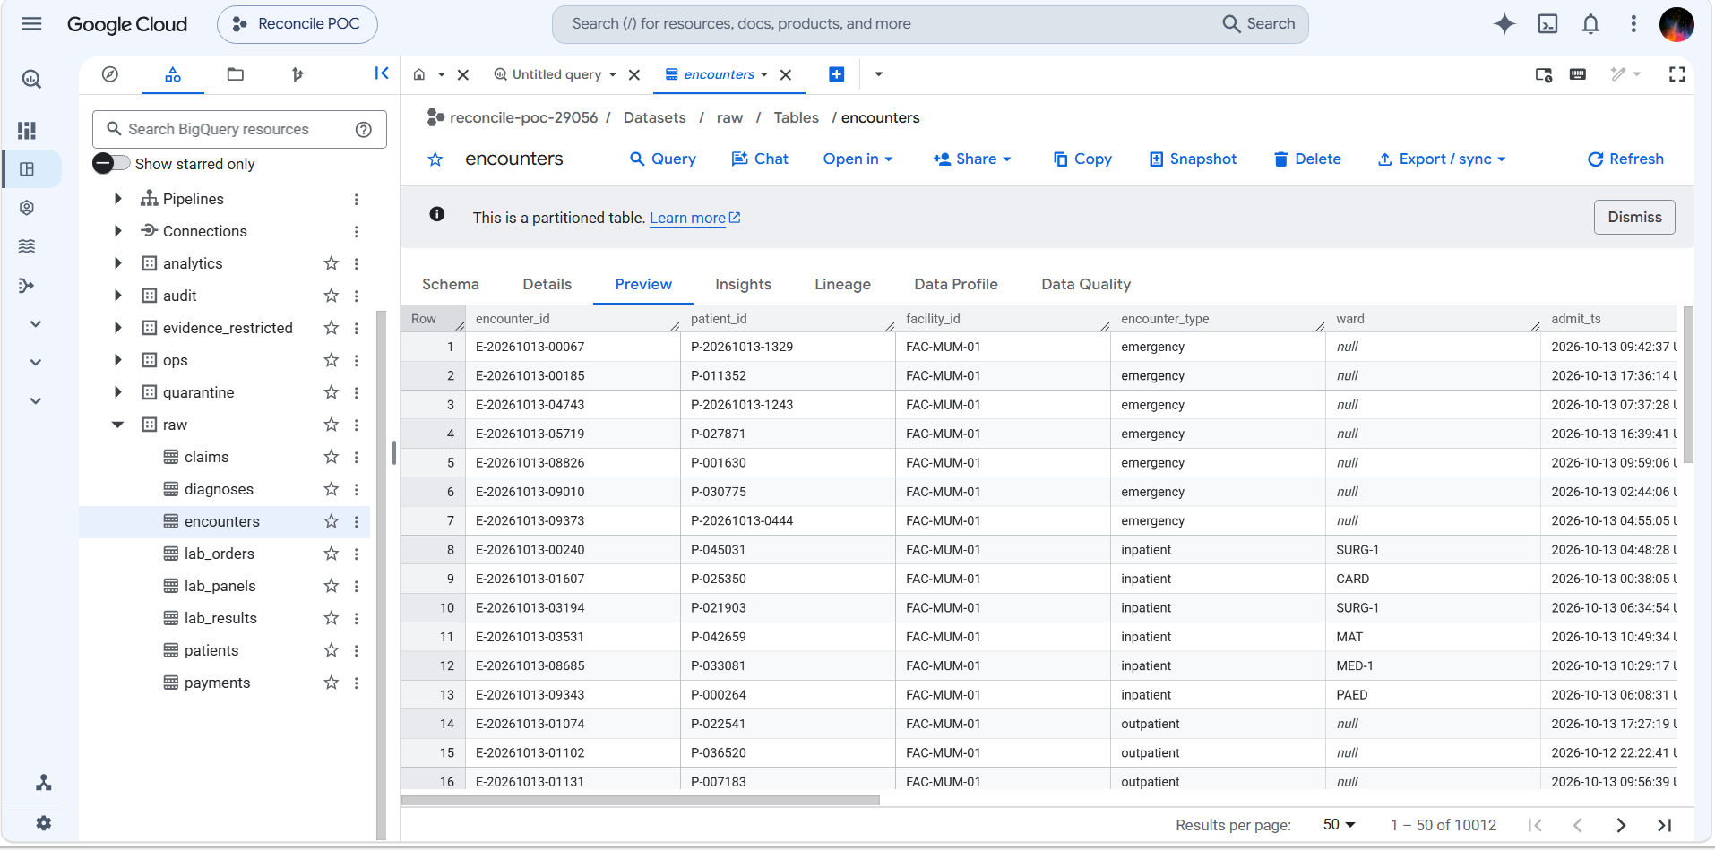
BigQuery raw.encounters after loading 13 Oct: 10,012 rows (matches the generator)
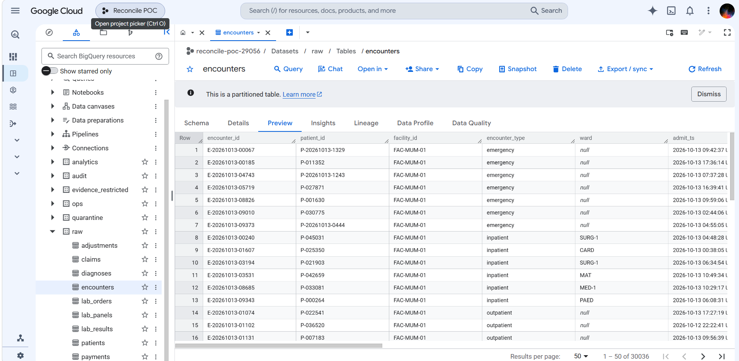
After loading 11, 12 and 13 Oct: 30,036 rows = 3 × 10,012
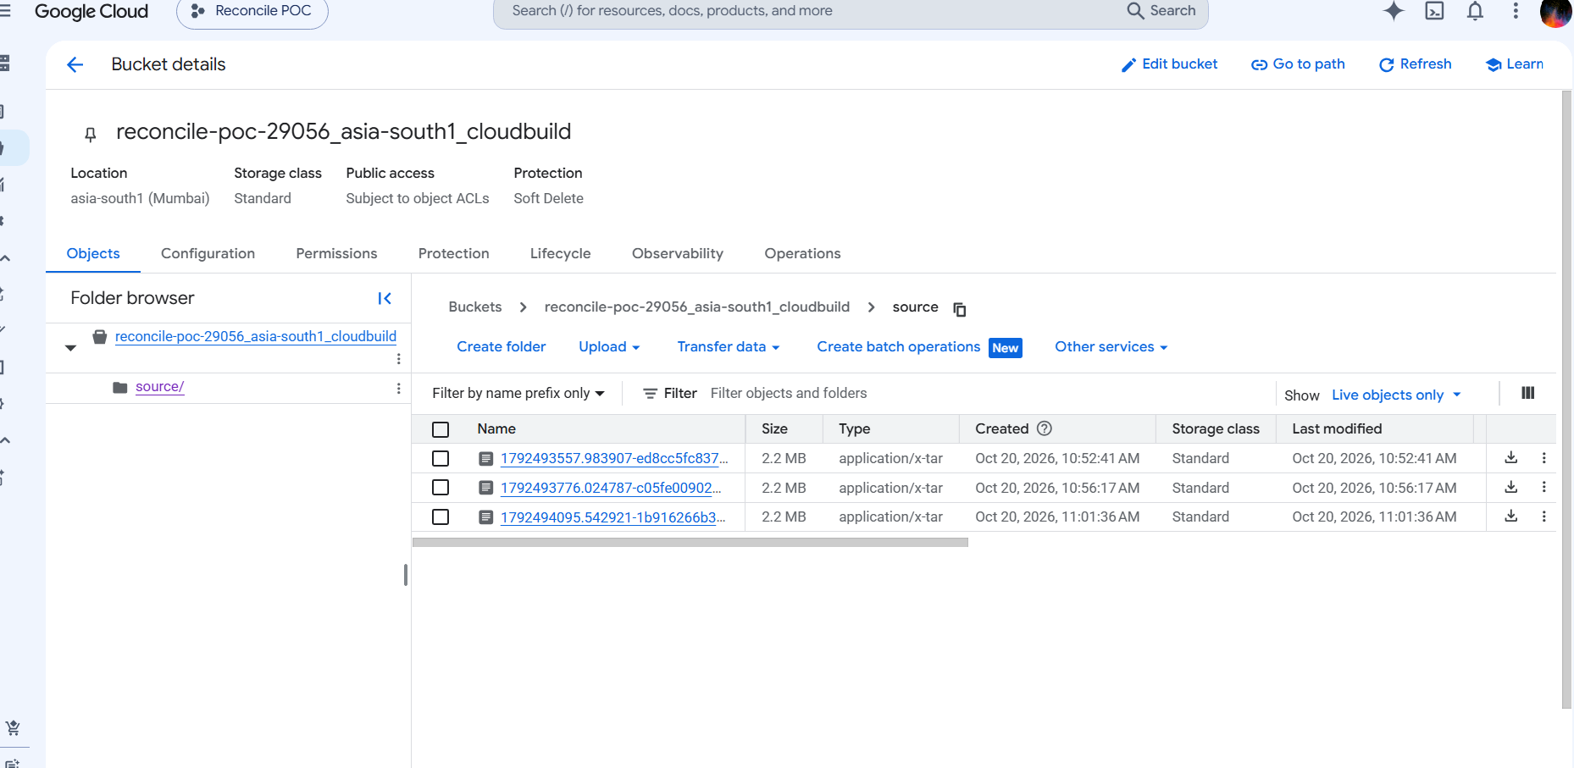
The *_cloudbuild bucket is created automatically by Cloud Build for console deploys — normal, not part of Terraform

5.5 Checking the receipts with SQL
Query 1 — every receipt per day. Totals look inflated because each re-load and each verify run writes its own receipt:
select business_date,
count(distinct dataset) as datasets,
sum(row_count) as total_rows -- note: "rows" is a reserved word in BigQuery
from `reconcile-poc-29056.ops.control_totals`
group by business_date
order by business_date;

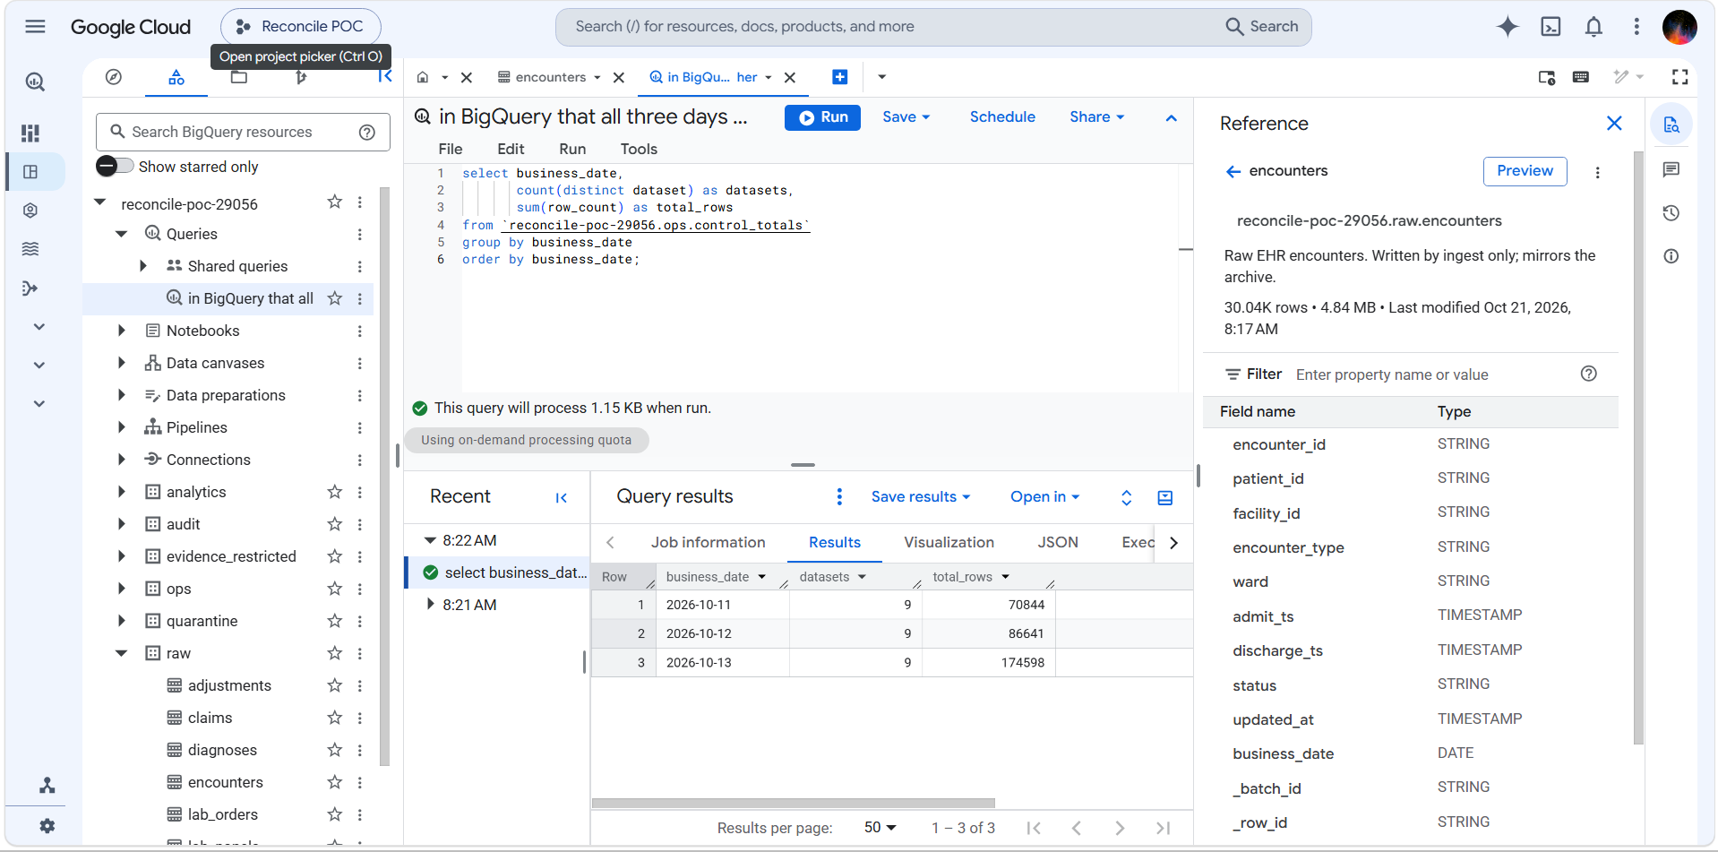
9 datasets every day; totals inflated by re-runs (13 Oct had the most)
Query 2 — the true size of each day (latest receipt per table and day):
select business_date, count(*) as datasets, sum(row_count) as total_rows
from (
select * from `reconcile-poc-29056.ops.control_totals`
qualify row_number() over (partition by business_date, dataset order by extracted_at desc) = 1
)
group by business_date
order by business_date;

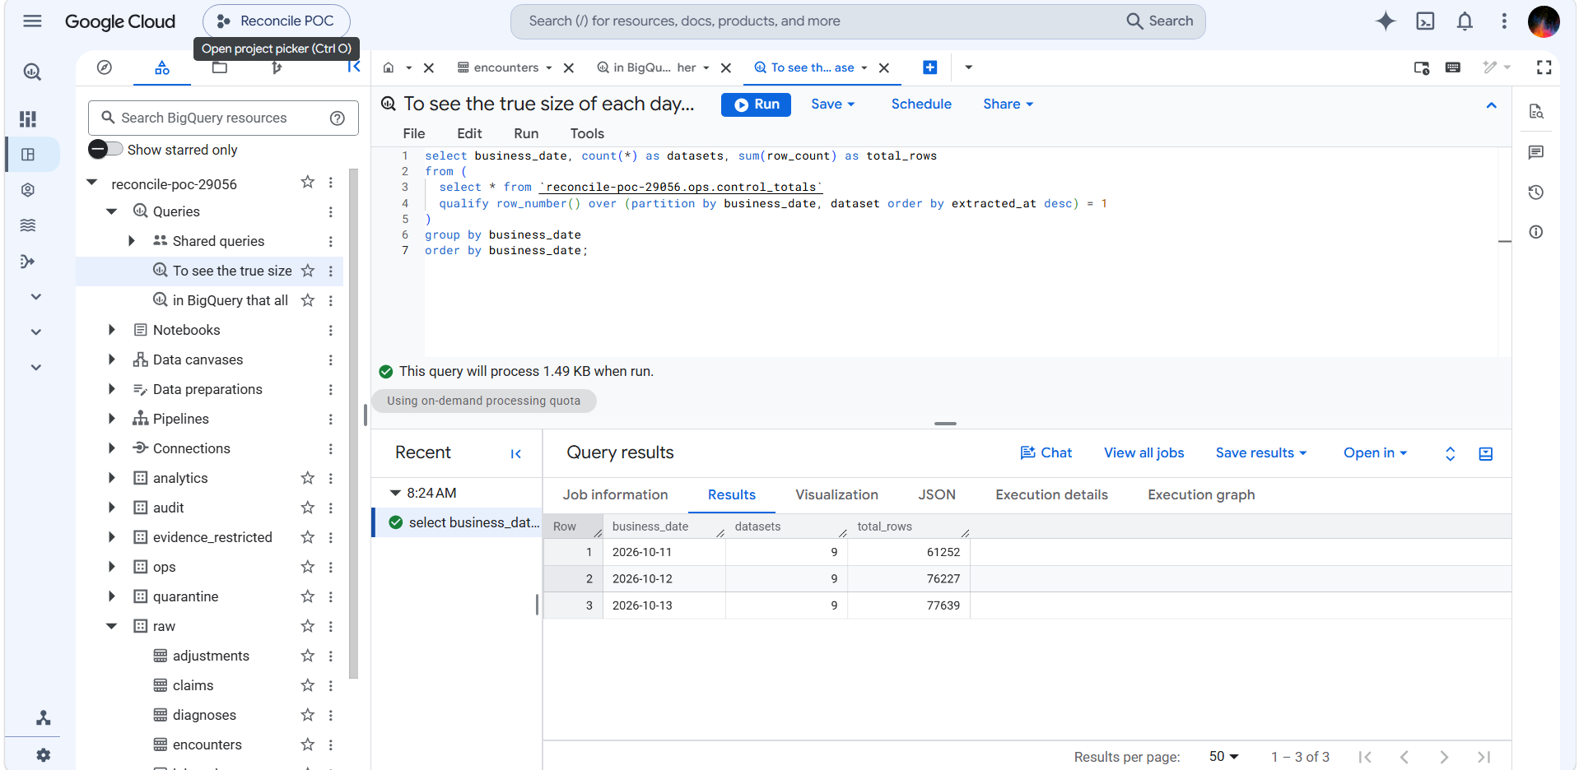
True day sizes: 11 Oct 61,252 · 12 Oct 76,227 · 13 Oct 77,639
Query 3 — which tables make 11 Oct smaller:
select dataset,
sum(if(business_date='2026-10-11', row_count, 0)) as oct_11,
sum(if(business_date='2026-10-12', row_count, 0)) as oct_12,
sum(if(business_date='2026-10-13', row_count, 0)) as oct_13
from (
select * from `reconcile-poc-29056.ops.control_totals`
qualify row_number() over (partition by business_date, dataset order by extracted_at desc) = 1
)
group by dataset
order by dataset;

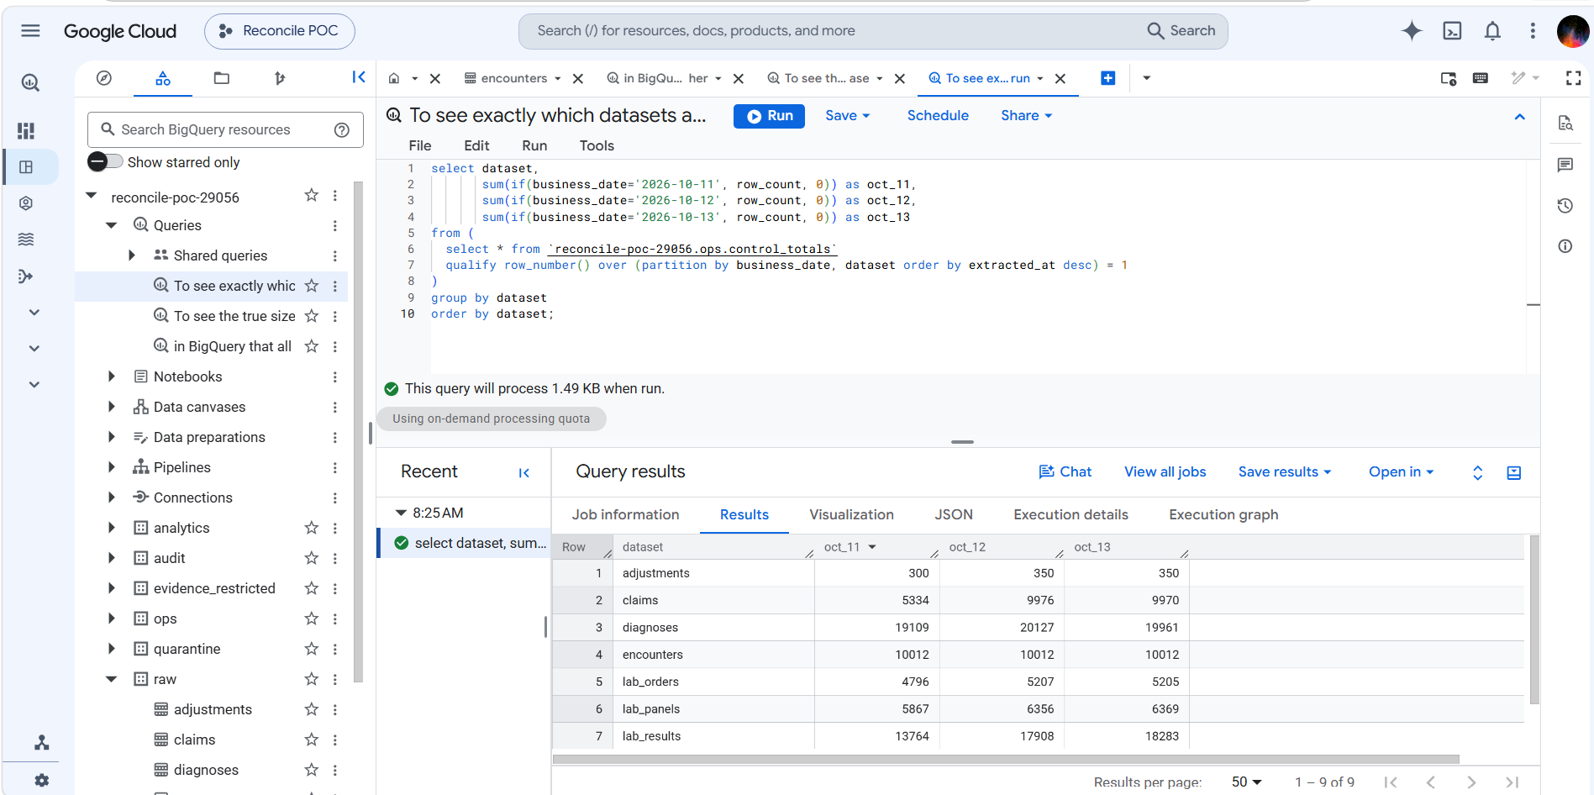
Encounters identical every day; claims and lab results short on 11 Oct
Example: 11 Oct is short because it is the first generated day. Its 00:00–05:30 IST slice falls on 10 Oct in UTC, which was never generated. Encounters are cut on the hospital-local day so they are complete; claims (5,334) and lab results (13,764) are recorded in UTC so they lose the early-morning slice. This is the built-in "UTC vs facility day" edge case, handled correctly. Use 12 and 13 Oct as the "normal" days.

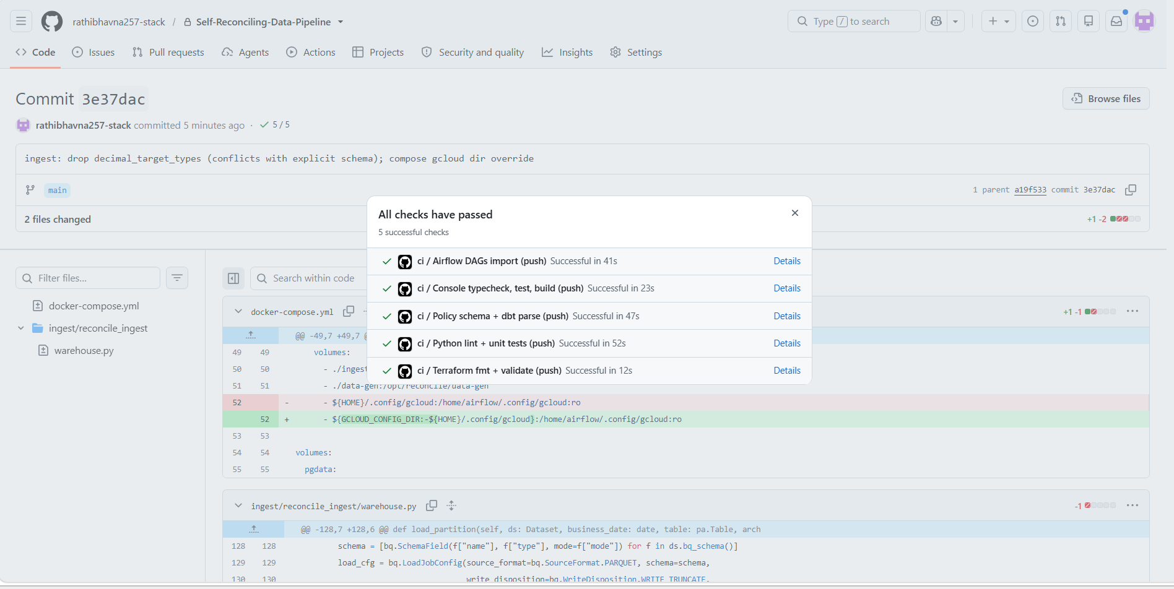
CI green on commit 3e37dac (load fix + Windows compose fix)

5.6 Housekeeping
make trigger unpauses the DAGs. Their schedule is 01:00 IST (19:30 UTC) and would load "yesterday", for which no data was generated. Switch the three DAG toggles off in the Airflow UI after manual runs (the CLI pause did not always take effect).
Why: The archive keeps an untouchable original of every load. If a load goes wrong, or the source has since archived the records, any day can be replayed exactly as received — this is what Phase 4's reextract_from_raw fix uses.

6. Phase 2 — dbt models and reconciliation checks
Status: ✅ exit gate passed 22 Oct 2026 — every planned failure is caught (T2–T7, T11) and evidence holds no values. The console Reconciliation screen is deferred to Phase 3.

What it does
dbt builds clean tables from raw into audit using SQL, and runs tests on them. Phase 2 adds the tests that compare each day with its receipt, so a load that "succeeded" but lost data is caught.
raw.<table> ──dbt build──► audit.stg_<table> ──► audit marts (dim_/fct_)
│
└── tests compare stg against ops.control_totals (the receipts)

Why: Phase 1 records the receipt; Phase 2 is where the warehouse is actually checked against it. Without these tests a green run still proves nothing about the data.

How a dbt build works
- You run dbt build --vars '{business_date: 2026-10-13}'.
- Each staging model reads raw for 13 Oct and the 2 days before (3-day look-back), keeps one row per ID per day (latest version), and replaces those 3 days in audit.
- Each model's tests run right after it is built.
- Marts are built from staging and tested.
- At the very end, a check confirms no test was skipped.

Files created in Phase 2
File (under dbt/reconcile/) | Purpose
models/staging/stg_encounters.sql | Clean encounters, dedupe by latest updated_at
models/staging/stg_claims.sql | Clean claims, dedupe by _source_snapshot_ts; adds is_reversed
models/staging/stg_lab_results.sql | Clean lab results
models/staging/_staging.yml | Tests attached to the staging models
tests/generic/reconcile_to_control_totals.sql | Data vs receipt (rows, IDs, empty amounts, ₹)
tests/generic/control_totals_present.sql | Every batch has exactly one receipt
tests/raw_claims_no_duplicates.sql | Warning when raw has duplicate claims (T4)
models/marts/dim_encounters.sql, fct_daily_claims.sql, fct_bed_occupancy.sql, _marts.yml | Report tables and their tests (step 6)
tests/fct_daily_claims_matches_staging.sql | Report adds up to staging (step 6)
macros/assert_expected_tests.sql, dbt_project.yml | Skipped-test rule, policy label default (step 7)
../../ingest/dags/dbt_build.py, ingest/Dockerfile, docker-compose.yml | dbt from Airflow (step 8)

Step 1 — Connect dbt to BigQuery
set -a; source .env; set +a # gives dbt GCP_PROJECT and SA_DBT
cd dbt/reconcile
dbt debug --profiles-dir . # → Connection test: [OK connection ok] · All checks passed!

dbt logs in with your Google login and borrows the sa-dbt identity (impersonation; no key file). It builds into audit.

Step 2 — First clean table: stg_encounters
One row per encounter per day; rebuilds only the chosen day plus 2 before it; full_refresh: false so history can never be wiped by accident.
{% set bd = var('business_date') %}
{% set lookback = var('lookback_days') | int %}
{{ config(materialized='incremental', incremental_strategy='insert_overwrite',
partition_by={'field': 'business_date', 'data_type': 'date'},
cluster_by=['encounter_id'], full_refresh=false, on_schema_change='append_new_columns') }}

with src as (
select * from {{ source('raw', 'encounters') }}
{% if is_incremental() %}
where business_date between date_sub(date('{{ bd }}'), interval {{ lookback - 1 }} day) and date('{{ bd }}')
{% endif %}
),
ranked as (
select *, row_number() over (partition by business_date, encounter_id
order by updated_at desc, _batch_id desc) as _rn
from src
)
select * except (_rn) from ranked where _rn = 1

dbt build --profiles-dir . --select stg_encounters --vars '{business_date: 2026-10-13}'
# first run: OK created … audit.stg_encounters [CREATE TABLE (30.0k rows)] · PASS=4
# re-runs: [SCRIPT …] = only the 3-day window is rebuilt

Step 3 — The reconciliation test
For each business date it takes the latest receipt (the batch currently in raw) and compares it with what landed in staging:
Check | Receipt column | Counted in staging
Rows | row_count | count(*)
Unique IDs | distinct_keys | count(distinct id)
Empty amounts (claims) | null_amount_count | countif(amount is null)
₹ total (claims) | amount_total | sum(amount)

{% test reconcile_to_control_totals(model, dataset, key_column, amount_column=none) %}
with receipt as (
select business_date, batch_id, row_count, distinct_keys, null_amount_count, amount_total
from {{ source('ops', 'control_totals') }}
where dataset = '{{ dataset }}' -- (+ 3-day window when business_date is set)
qualify row_number() over (partition by business_date order by extracted_at desc) = 1
),
landed as (
select business_date, count(*) as rows_landed, count(distinct {{ key_column }}) as distinct_landed
{% if amount_column %}, countif({{ amount_column }} is null) as null_amount_landed,
sum({{ amount_column }}) as amount_landed {% endif %}
from {{ model }} group by business_date
)
select r.*, l.* from receipt r left join landed l using (business_date)
where l.business_date is null or l.rows_landed != r.row_count or l.distinct_landed != r.distinct_keys
{% if amount_column %} or l.null_amount_landed != r.null_amount_count
or coalesce(l.amount_landed,0) != coalesce(r.amount_total,0) {% endif %}
{% endtest %}

Attached in _staging.yml (arguments nested under arguments: for dbt 1.12):
- name: stg_encounters
data_tests:
- reconcile_to_control_totals:
arguments: {dataset: encounters, key_column: encounter_id}
config: {meta: {policy_outcome: blocking}}
- control_totals_present:
arguments: {dataset: encounters}
config: {meta: {policy_outcome: blocking}}

Step 3 demo — break it on purpose: drop_hour (test T3)
Reload 13 Oct encounters with the drop_hour injector. It loses the 02:00–03:00 rows during the load, but the receipt is still counted from the full source.
docker compose exec airflow airflow dags trigger ingest_ehr \
--conf '{"business_date":"2026-10-13","datasets":["encounters"],"inject":["drop_hour"]}'

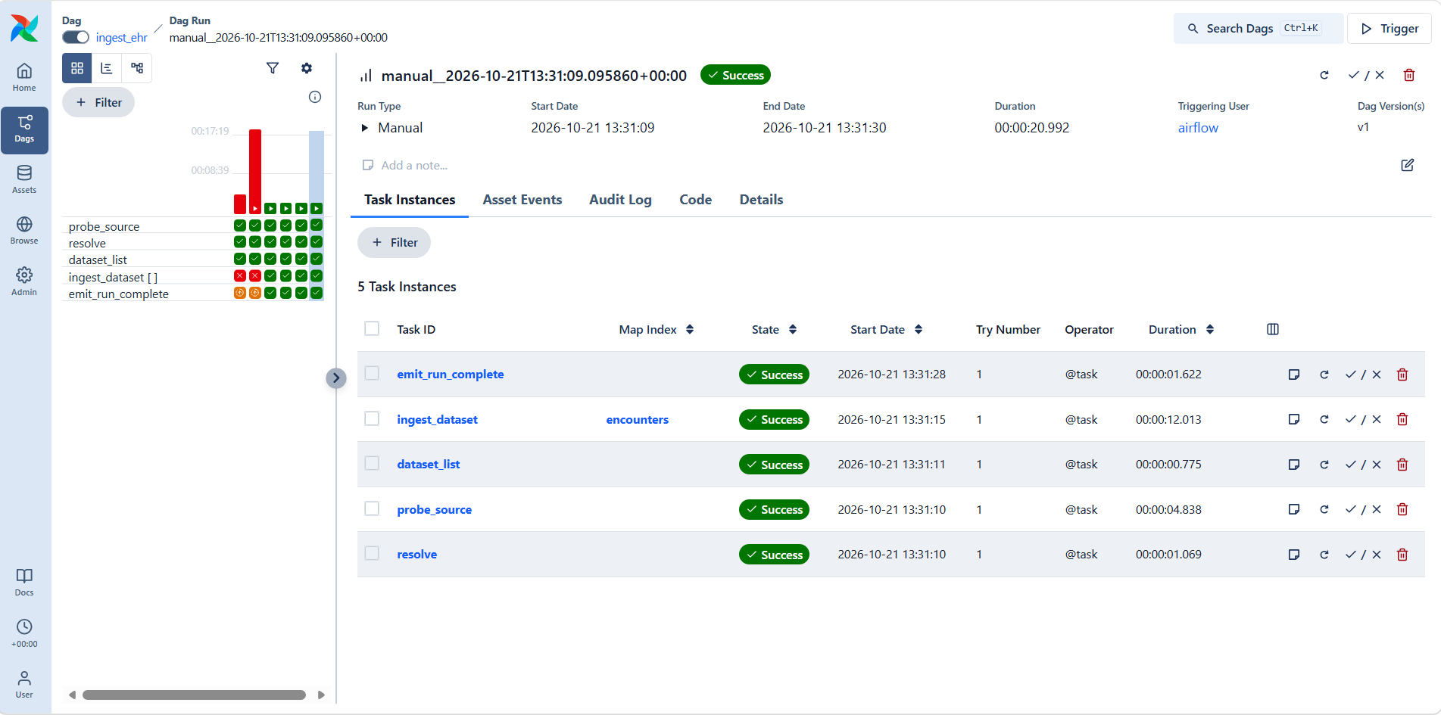
The injected run is green in Airflow — the hidden failure the POC exists to catch
dbt build --profiles-dir . --select stg_encounters --vars '{business_date: 2026-10-13}'
4 of 5 FAIL 1 reconcile_to_control_totals_stg_encounters_encounters__encounter_id
Done. PASS=4 WARN=0 ERROR=1

Run the test's compiled SQL (from target/compiled/…) in BigQuery to see exactly what it found:
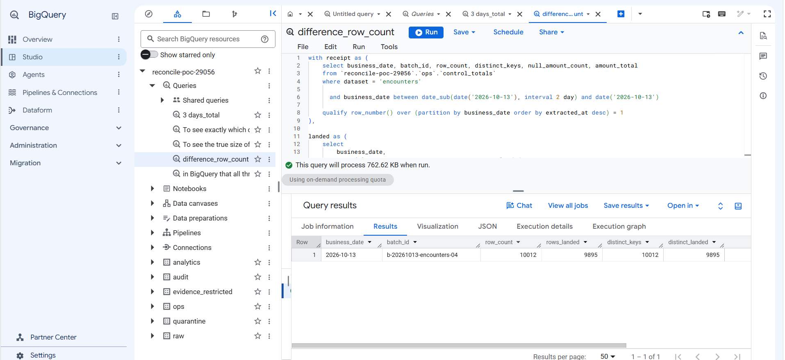
Receipt 10,012 vs landed 9,895 for batch b-20261013-encounters-04: 117 encounters missing
Repair: reload cleanly, rebuild, re-check — what Phase 4 will automate:
docker compose exec airflow airflow dags trigger ingest_ehr \
--conf '{"business_date":"2026-10-13","datasets":["encounters"]}'
dbt build --profiles-dir . --select stg_encounters --vars '{business_date: 2026-10-13}' # → PASS=5

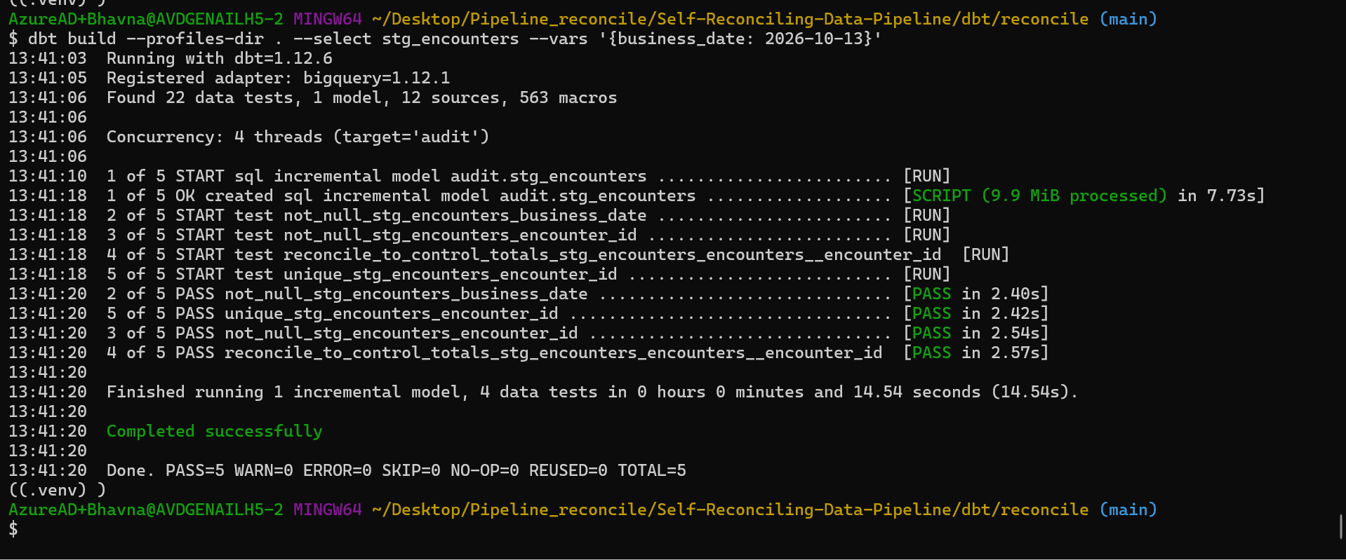
After the clean reload: all 5 checks pass again
Result: Airflow said green, the receipt check caught 117 missing records and named the exact day and batch, and a reload plus rebuild fixed and proved it. This is demo scenario 1, done by hand.

Step 4 — Every batch must have a receipt (test T2)
Why a second test: the reconciliation test uses the *latest* receipt. If a new load's receipt is never written, it silently compares against an older receipt and may pass.
{% test control_totals_present(model, dataset) %}
with batches as (select distinct business_date, _batch_id as batch_id from {{ model }}),
receipts as (select business_date, batch_id, count(*) as receipts
from {{ source('ops', 'control_totals') }} where dataset = '{{ dataset }}'
group by business_date, batch_id)
select b.*, coalesce(r.receipts, 0) as receipts
from batches b left join receipts r using (business_date, batch_id)
where coalesce(r.receipts, 0) != 1
{% endtest %}

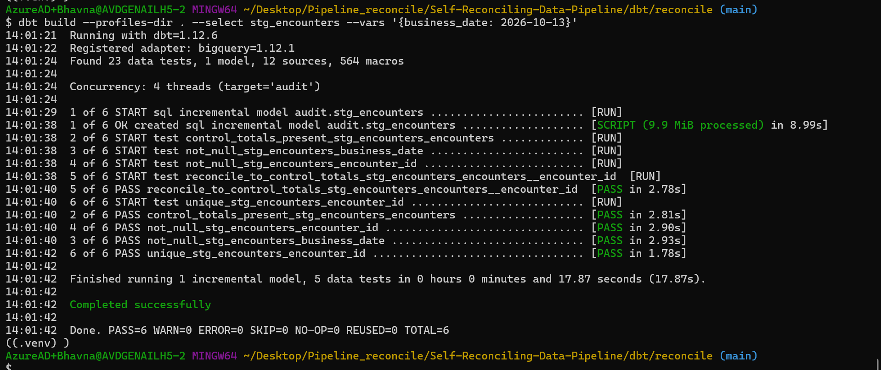
Clean data: PASS=6 including control_totals_present
docker compose exec airflow airflow dags trigger ingest_ehr \
--conf '{"business_date":"2026-10-13","datasets":["encounters"],"inject":["missing_control_totals"]}'

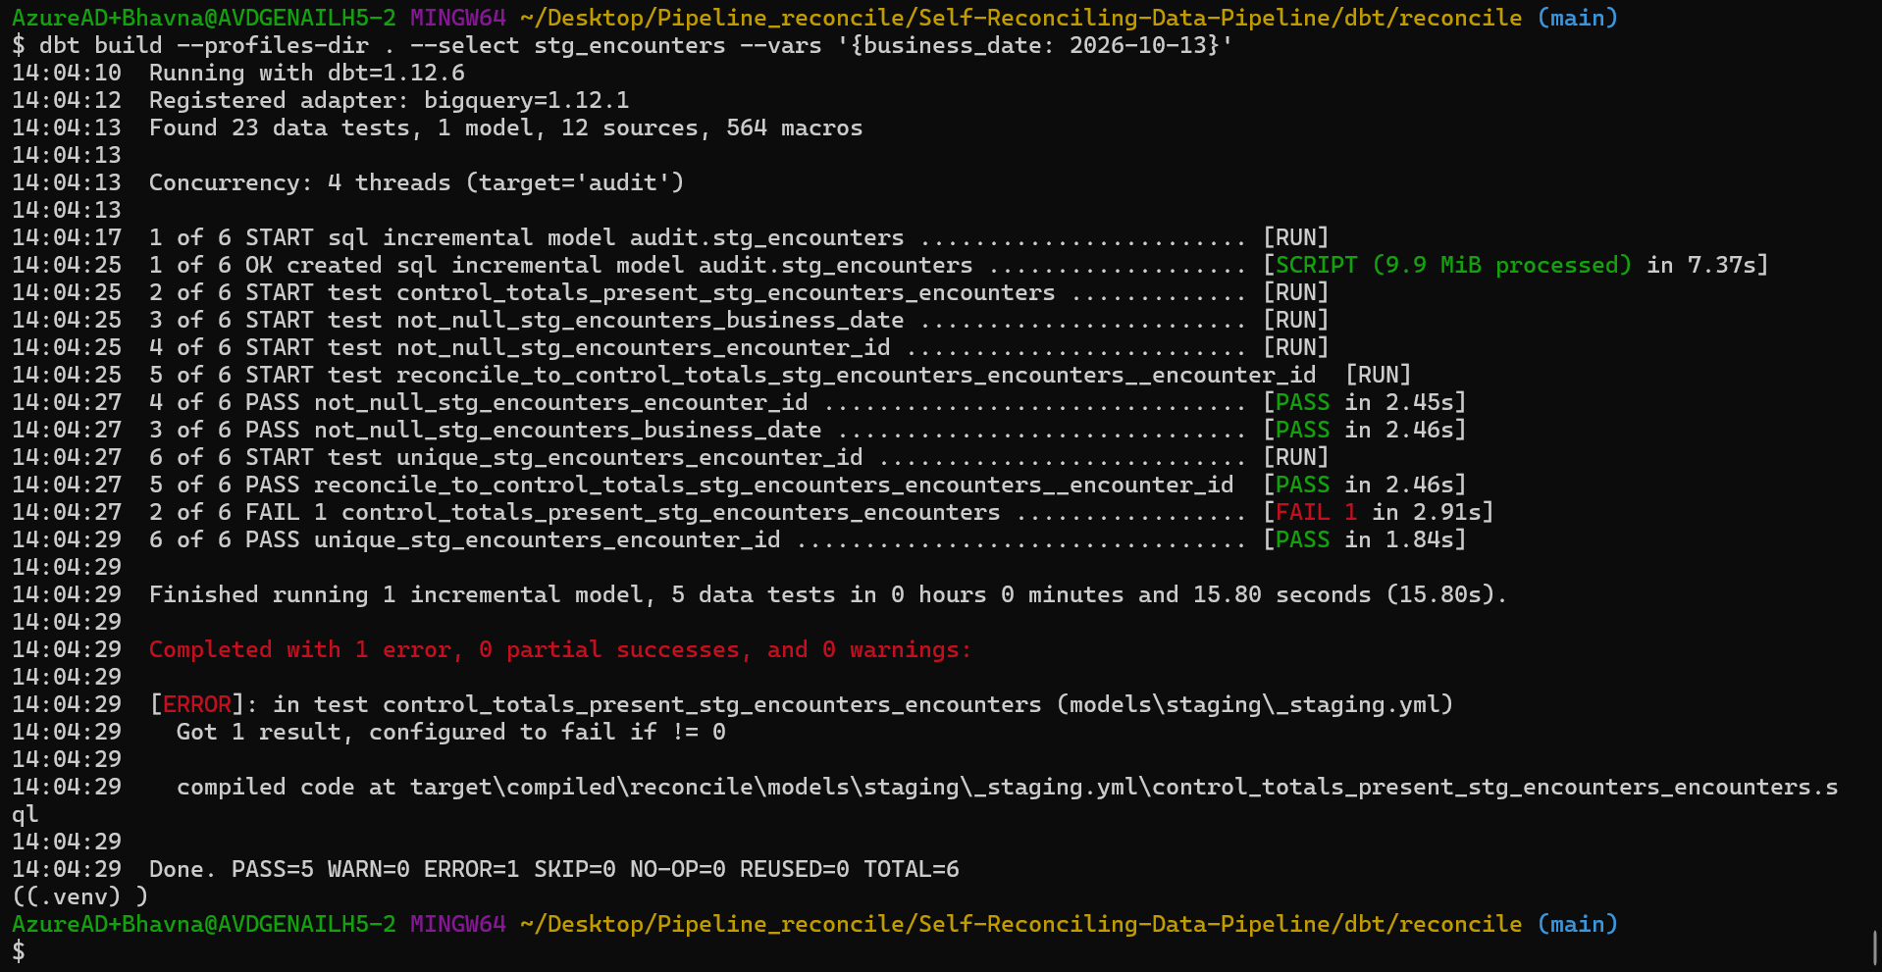
Load without a receipt: reconciliation PASSES (fooled by the old receipt), control_totals_present FAILS
Result: Both tests are needed. Repair is the same: clean reload, rebuild, PASS=6.

Step 5 — Claims (with ₹ totals) and lab results
Before writing the models, check the columns and which money column each receipt uses:
bq show --schema --format=prettyjson reconcile-poc-29056:raw.claims | grep '"name"'
grep -n -B2 -A15 'claims' ingest/reconcile_ingest/datasets.py

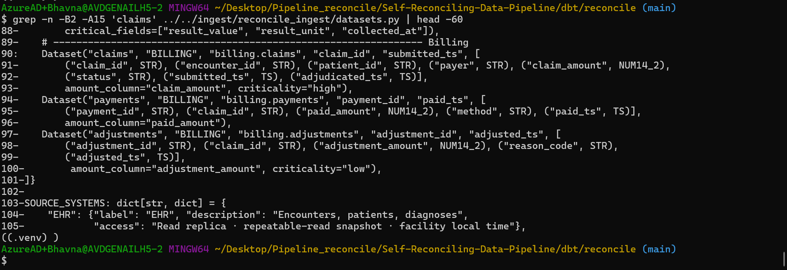
datasets.py: claims are dated by submitted_ts, key claim_id, money column claim_amount
select dataset, any_value(key_column) key_column, any_value(amount_column) amount_column
from `reconcile-poc-29056.ops.control_totals`
where dataset in ('claims', 'lab_results', 'encounters')
group by dataset;

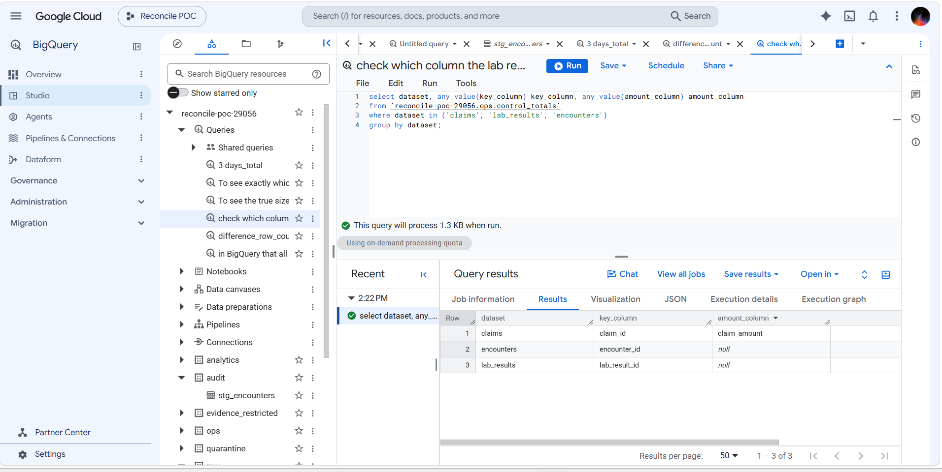
Only claims has a money column (claim_amount); lab results reconcile on rows and IDs
stg_claims follows the same pattern as encounters, but claims have no updated_at, so the latest version wins by _source_snapshot_ts. It adds is_reversed (status = 'reversed'). Its reconciliation also compares empty amounts and the ₹ total (amount_column: claim_amount). A warning test flags duplicate claims in raw.
dbt build --profiles-dir . --select staging raw_claims_no_duplicates --vars '{business_date: 2026-10-13}'
# audit.stg_lab_results CREATE TABLE (50.0k rows) = 13,764 + 17,908 + 18,283
# audit.stg_claims CREATE TABLE (25.3k rows) = 5,334 + 9,976 + 9,970
# Done. PASS=19

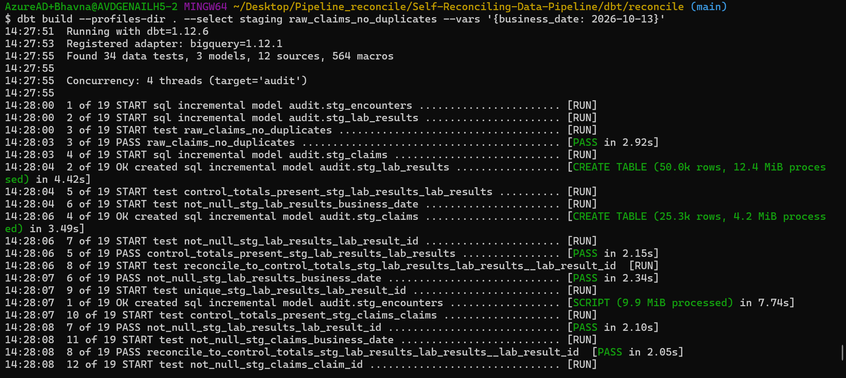
Building all three staging models
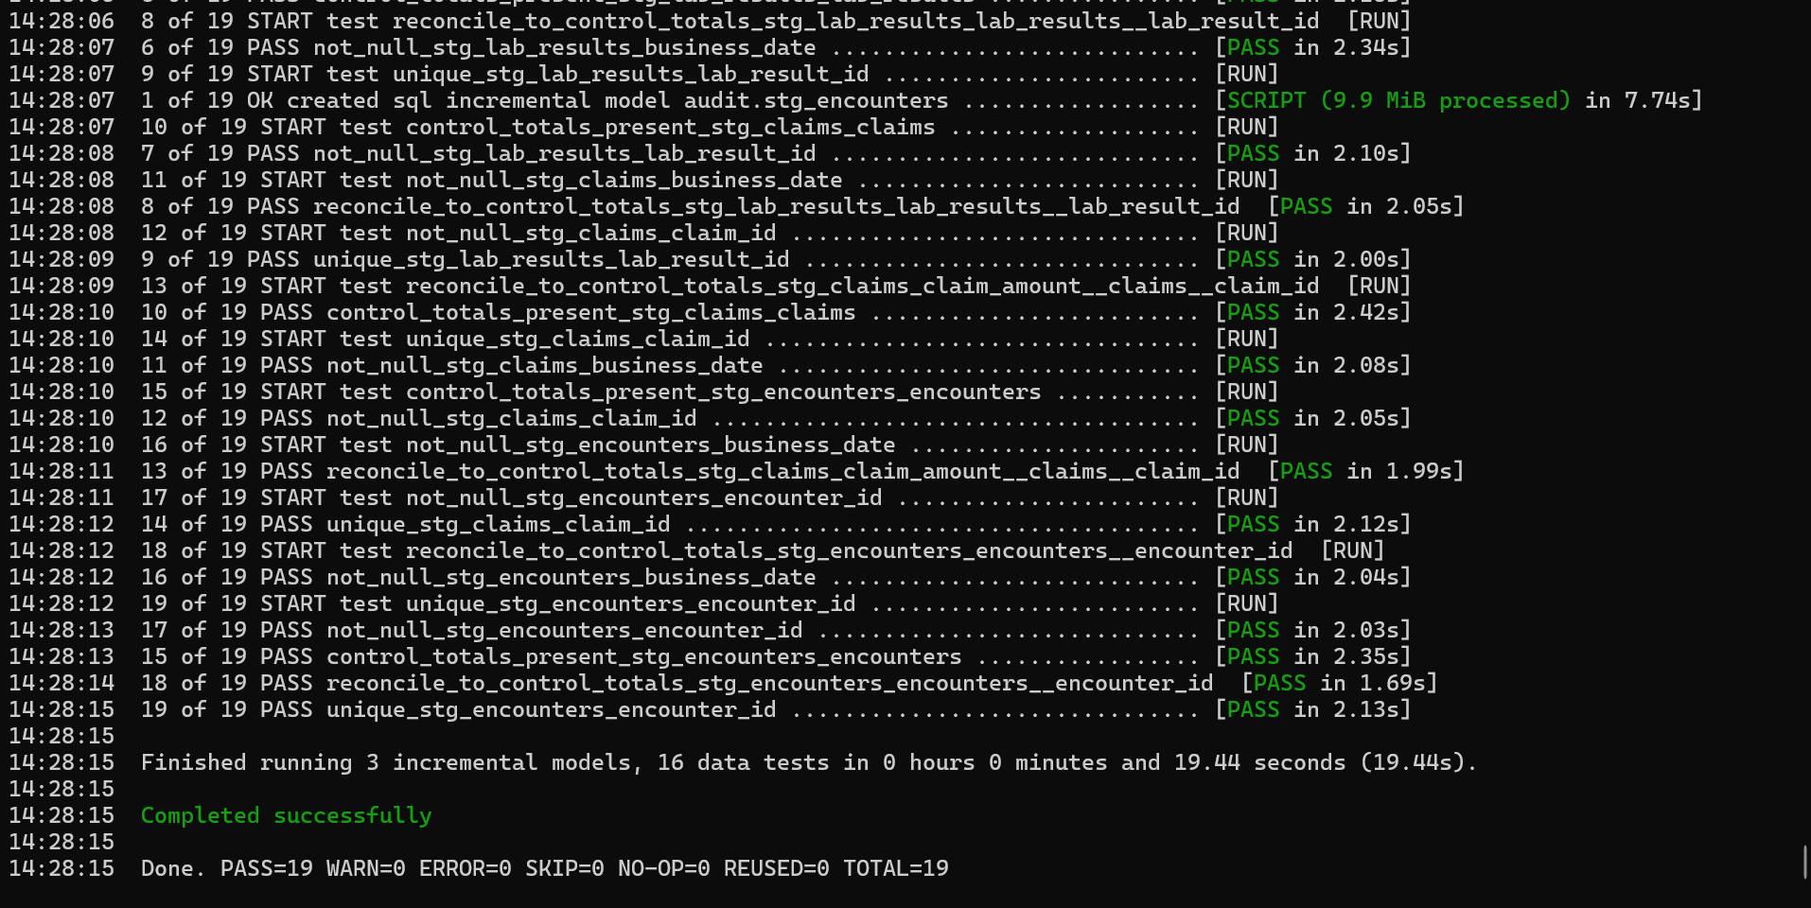
All 19 checks pass, including the ₹ total for claims

Step 5 demo — the 3-day look-back catches late reversals
A claim reversed days after it was loaded changes an old day. The look-back needs two halves: re-extract recent days (ingest) and rebuild recent days (dbt).
select business_date, status, count(*) as claims, sum(claim_amount) as amount
from `reconcile-poc-29056.audit.stg_claims`
group by business_date, status
order by business_date, status;

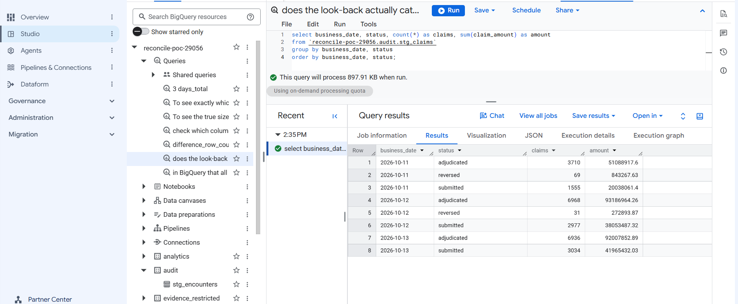
Before: 12 Oct has 31 reversed claims, 13 Oct has none
make generate DATE=2026-10-14 DAYS=1 # 14 Oct reverses some earlier claims in the source
make trigger DATE=2026-10-14
docker compose exec airflow airflow dags trigger ingest_billing --conf '{"business_date":"2026-10-12","datasets":["claims"]}'
docker compose exec airflow airflow dags trigger ingest_billing --conf '{"business_date":"2026-10-13","datasets":["claims"]}'
dbt build --profiles-dir . --select staging raw_claims_no_duplicates --vars '{business_date: 2026-10-14}' # PASS=19

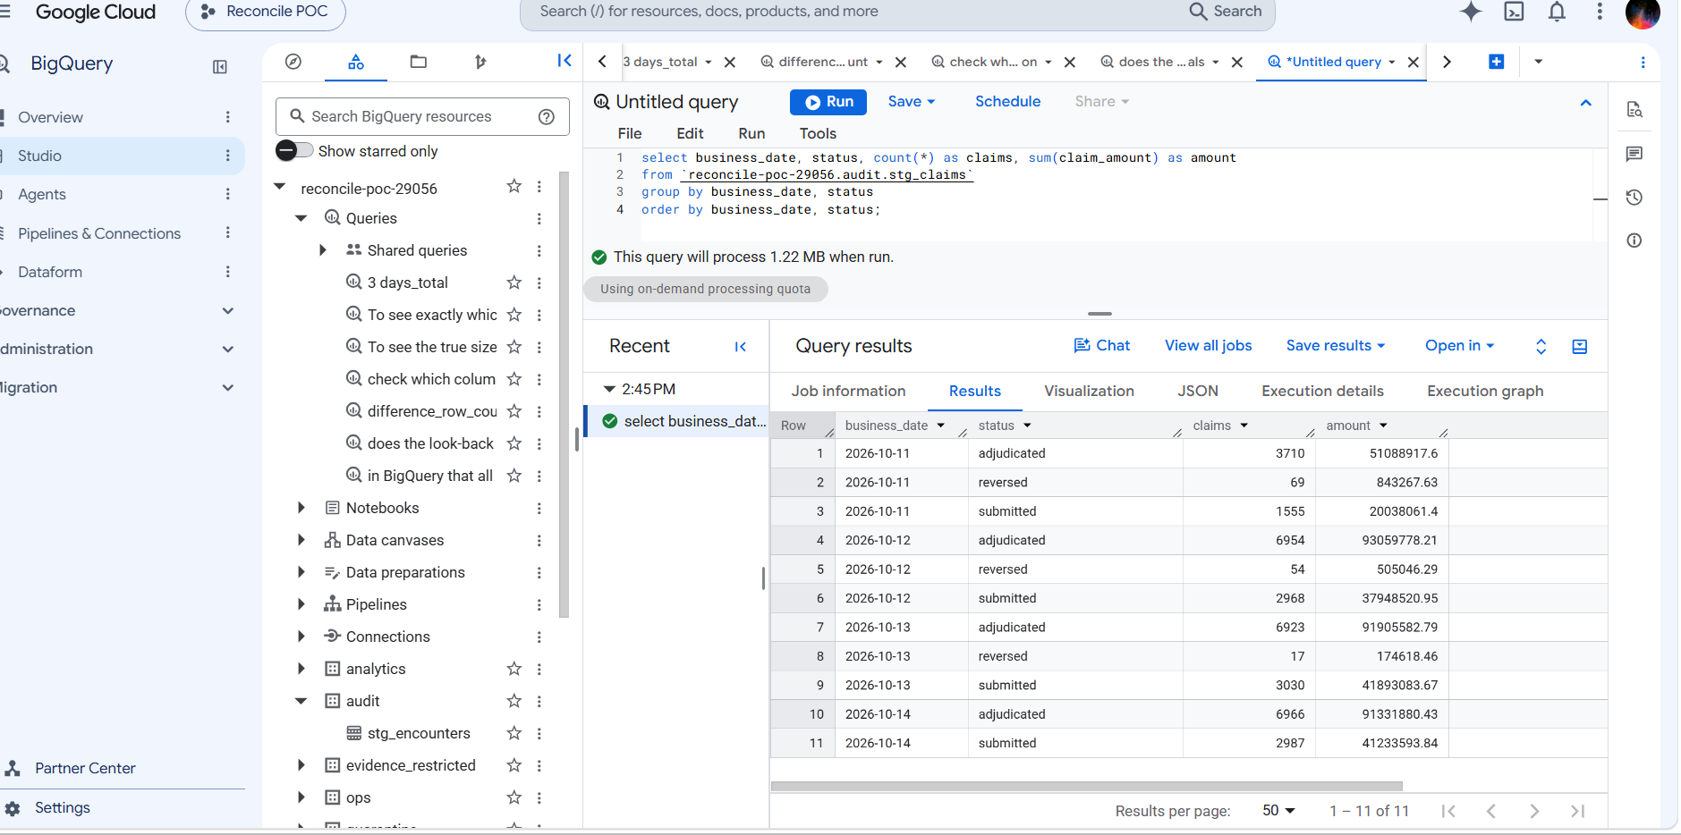
After: 12 Oct 31 → 54 reversed (₹505,046), 13 Oct 0 → 17 (₹174,618); 11 Oct unchanged (outside the window)
Result: Late reversals reach the warehouse and the ₹ totals still reconcile against the fresh receipts. 11 Oct shows the limit of a 3-day window.

Watch: Gap found: the billing ingest does not re-extract recent days by itself — the "3-day lookback" text is only a console label. Re-loads were manual here; automating them is a follow-up (or Phase 4's lookback_rebuild).

Which problems Phase 2 catches
Problem | Example | Caught by | Outcome
Missing rows | drop_hour: 117 encounters lost, job green | rows / IDs ≠ receipt | Fail ✅ proven
Missing receipt | missing_control_totals | control_totals_present | Fail ✅ proven
Duplicates in raw | Retry loads claims twice | Staging dedupes; raw test warns | Warning ✅ proven
Offsetting errors | 50 missing + 50 duplicated | Unique IDs and ₹ ≠ receipt | Fail ✅ proven
Wrong money | Amount altered | ₹ total ≠ receipt | Fail
Empty / repeated IDs | — | not_null, unique | Fail
Late reversals | Claim reversed 2 days later | 3-day look-back rebuild | Handled ✅ proven
Report bug | Bad join in a mart | mart-vs-staging test (step 6) | Fail (passes on clean data ✅)
Skipped check | A test excluded | Expected-test-count (step 7) | Fail ✅ proven
Unit change | Glucose mg/dL → mmol/L | Unit / range check (step 9) | Fail ✅ proven
Value corruption | 14 results rounded by a release | KMS value-level check (step 11) | Fail ✅ proven

Step 6 — Report tables (marts)
The tables reports will read once Phase 3 publishes them, built from staging into audit:
Table | One row per | Used for
dim_encounters | encounter (latest version) | visit details, length of stay, open/closed
fct_daily_claims | day × payer × encounter type | claims, reversed claims, gross ₹ and net ₹ (excludes reversed)
fct_bed_occupancy | day × ward | inpatient admissions, discharges, beds occupied at midnight (IST)

Why: fct_daily_claims joins dim_encounters on purpose. In Phase 3 that dependency means a held encounters day also holds the claims report, so a report never mixes verified and unverified data.

-- models/marts/fct_daily_claims.sql (core)
select c.business_date, c.payer, coalesce(e.encounter_type, 'unknown') as encounter_type,
count(*) as claims, countif(c.is_reversed) as reversed_claims,
sum(c.claim_amount) as gross_amount,
sum(if(c.is_reversed, 0, c.claim_amount)) as net_amount,
countif(e.encounter_id is null) as claims_without_encounter
from {{ ref('stg_claims') }} c
left join {{ ref('dim_encounters') }} e using (encounter_id)
group by 1, 2, 3

A test, tests/fct_daily_claims_matches_staging.sql, checks that the report carries exactly the claims and ₹ of staging, day by day — a bad join or filter in the mart would fail it.
dbt build --profiles-dir . --vars '{business_date: 2026-10-14}'
# dim_encounters CREATE TABLE (40.0k rows) = 4 days × 10,012
# fct_daily_claims CREATE TABLE (84 rows) = 4 days × payer × encounter type
# fct_bed_occupancy CREATE TABLE (32 rows) = 4 days × 8 wards
# PASS fct_daily_claims_matches_staging
# Expected-test-count check passed: every test on the 6 built model(s) ran.
# Done. PASS=49 WARN=0 ERROR=0

select business_date, sum(claims) claims, sum(reversed_claims) reversed,
sum(gross_amount) gross, sum(net_amount) net
from `reconcile-poc-29056.audit.fct_daily_claims`
group by 1 order by 1;

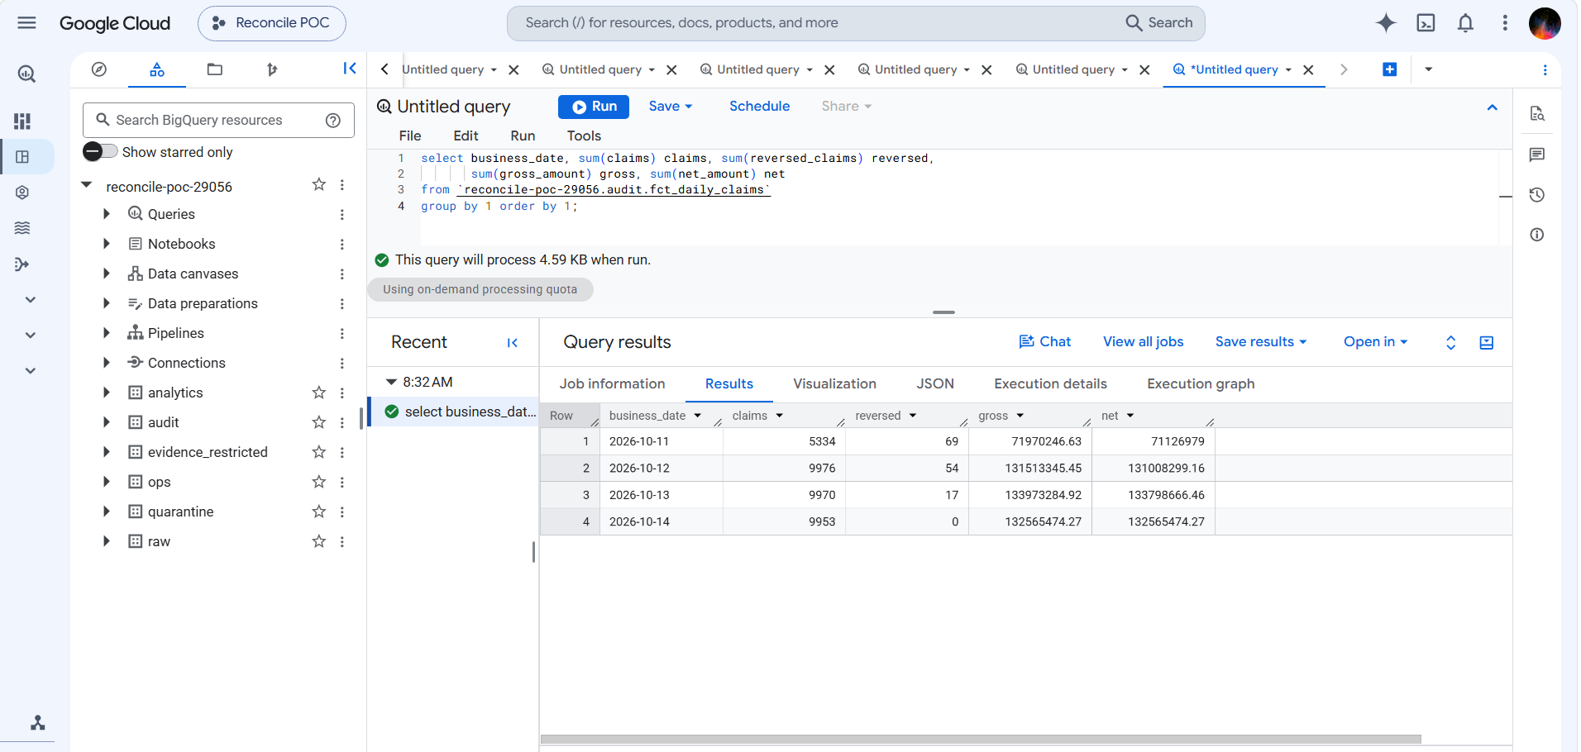
Daily claims report: gross − net equals the reversed ₹ exactly (11 Oct 843,267.63 · 12 Oct 505,046.29 · 13 Oct 174,618.46)
Result: The report is correct to the paisa: for every day, gross minus net equals the ₹ of reversed claims found in staging, and staging matches the source receipts.

Step 7 — Safety rules: policy labels and "a skipped test is a failure" (T7)
- Policy label on every test. dbt_project.yml gives every test meta.policy_outcome: blocking by default; the raw-duplicate test overrides it to warning. The Phase 3 gate reads this label to decide hold vs publish.
- Expected-test-count check. A macro, macros/assert_expected_tests.sql, runs at the end of every dbt run (on-run-end). For every model built in the run, every test attached to it must also have run; otherwise the whole run fails.

Why: Without it, someone could run dbt build --exclude <a test> and get a green build that quietly skipped a check.

# dbt_project.yml (additions)
vars:
enforce_test_count: true
on-run-end:
- "{{ assert_expected_tests(results) }}"
data_tests:
reconcile:
+meta:
policy_outcome: blocking

dbt build --profiles-dir . --select stg_encounters \
--exclude unique_stg_encounters_encounter_id --vars '{business_date: 2026-10-14}'
# model and 4 tests PASS, then:
# Compilation Error in operation reconcile-on-run-end-0
# Expected-test-count check FAILED: 1 test(s) on built models did not run: unique_stg_encounters_encounter_id

Result: A skipped check can no longer look like a pass. ("Exited because of keyboard interrupt" in that output is dbt's wording for a failure in an end-of-run hook; nothing was pressed.)

Step 8 — Run dbt from Airflow
A new DAG, dbt_build, runs the same dbt build for a given business date inside the Airflow container, so it can run after ingest (manually now; triggered by the engine in Phase 4).
Change | Why
ingest/Dockerfile: dbt-core 1.12.6 + dbt-bigquery 1.12.1 in its own virtualenv /home/airflow/dbt-venv | Airflow pins library versions through a constraints file; a separate environment stops dbt and Airflow breaking each other
docker-compose.yml: - ./dbt:/opt/reconcile/dbt under the airflow volumes | Makes the dbt project visible inside the container; edits apply without rebuilding
ingest/dags/dbt_build.py | Two tasks: dbt_debug (connection as sa-dbt) → dbt_build_and_test; business_date from the trigger, validated as YYYY-MM-DD

# ingest/Dockerfile (added)
RUN python -m venv /home/airflow/dbt-venv \
&& /home/airflow/dbt-venv/bin/pip install --no-cache-dir dbt-core==1.12.6 dbt-bigquery==1.12.1

# ingest/dags/dbt_build.py (core)
DBT = "/home/airflow/dbt-venv/bin/dbt"
PROJECT_DIR = "/opt/reconcile/dbt/reconcile"
DBT_ENV = "DBT_TARGET_PATH=/tmp/dbt-target DBT_LOG_PATH=/tmp/dbt-logs" # build output stays in the container

@dag(dag_id="dbt_build", schedule=None, catchup=False, max_active_runs=1,
params={"business_date": Param("2026-10-14", type="string")})
def dbt_build():
@task.bash
def dbt_debug() -> str:
return f"cd {PROJECT_DIR} && {DBT_ENV} {DBT} debug --profiles-dir ."

@task.bash
def dbt_build_and_test() -> str:
bd = _business_date() # validated YYYY-MM-DD
return f"cd {PROJECT_DIR} && {DBT_ENV} {DBT} build --profiles-dir . --vars '{{business_date: {bd}}}'"

dbt_debug() >> dbt_build_and_test()

make down && make up # rebuilds the image with dbt (~19 min the first time on the company network)
docker compose exec airflow /home/airflow/dbt-venv/bin/dbt --version # core 1.12.6, bigquery 1.12.1
docker compose exec airflow ls /opt/reconcile/dbt/reconcile # dbt_project.yml, models, macros, tests …
docker compose exec airflow airflow dags unpause dbt_build # safe: no schedule
docker compose exec airflow airflow dags trigger dbt_build --conf '{"business_date":"2026-10-14"}'

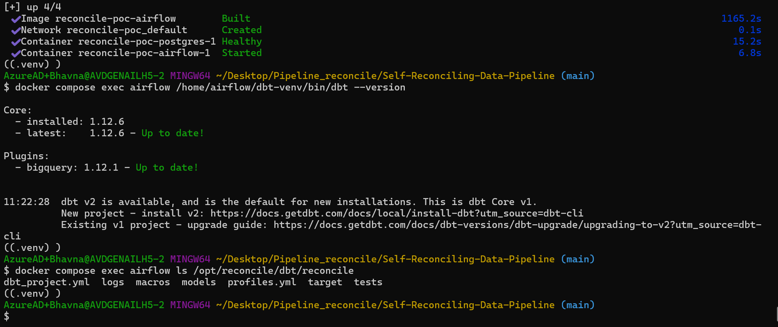
Image rebuilt; dbt 1.12.6 + bigquery 1.12.1 inside the container; dbt project mounted
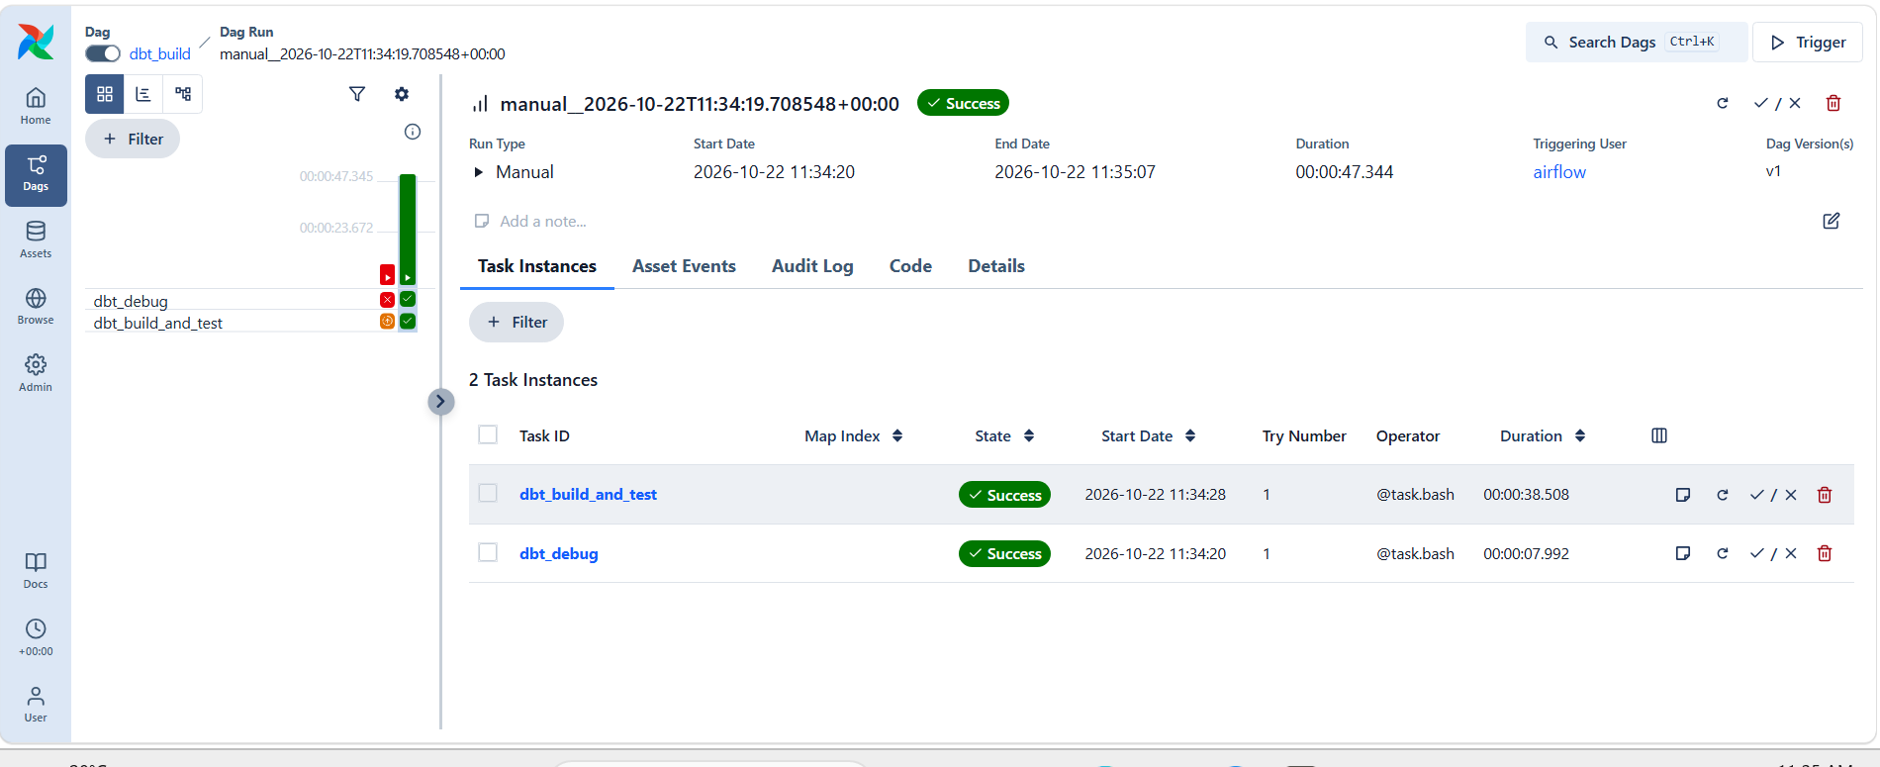
dbt_build run: dbt_debug and dbt_build_and_test green (the earlier red run is the --target-path issue below)
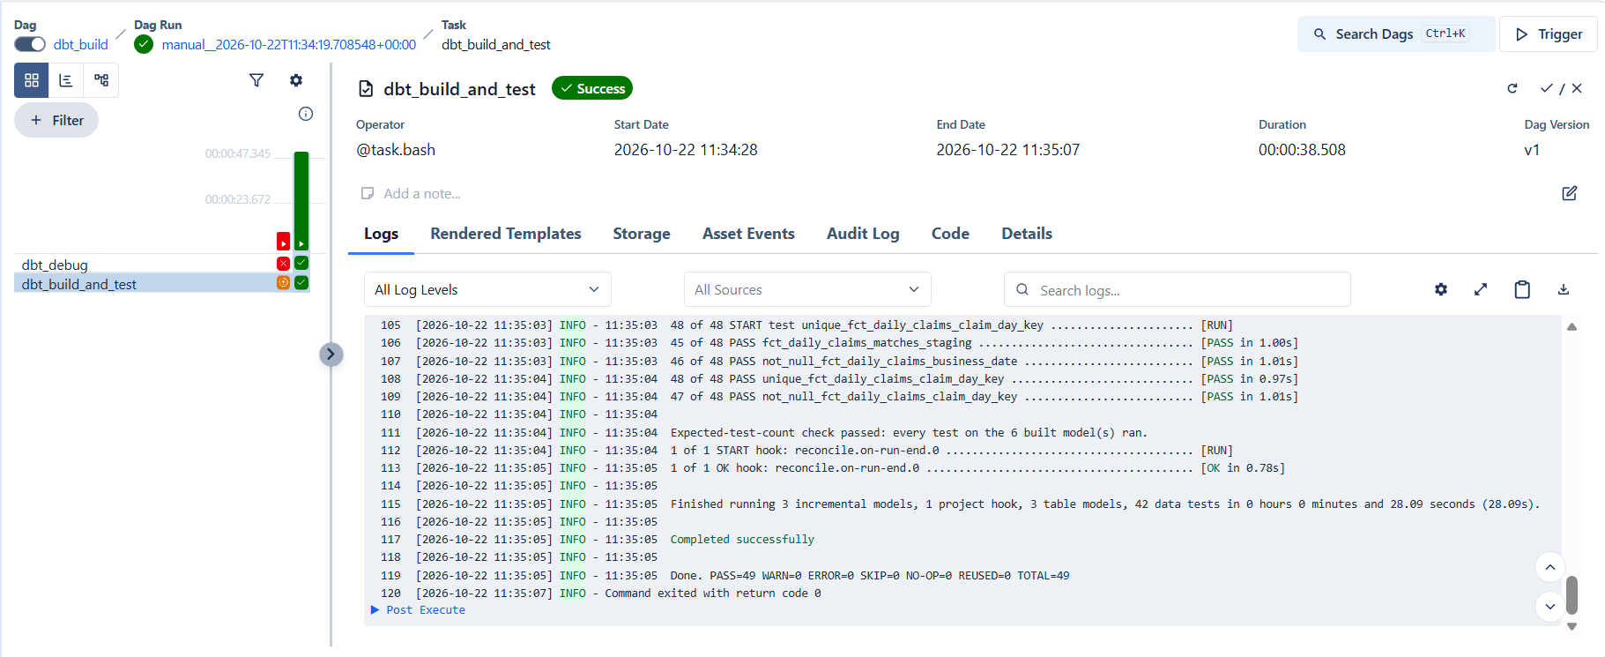
Task log in Airflow: Expected-test-count check passed · PASS=49 · return code 0
Watch: First run failed: dbt debug does not accept --target-path. Fixed by setting DBT_TARGET_PATH and DBT_LOG_PATH as environment variables, which every dbt command understands. To see a task's real error quickly, run the same command with docker compose exec airflow bash -c "…".

Step 9 — Lab unit and range check (T11)
Counts and IDs stay identical when the lab system switches glucose from mg/dL to mmol/L — every value is just ~18× smaller. Receipts cannot see that; a value check can.
- models/reference/lab_reference_ranges.sql — expected unit and plausible range per test (12 tests), derived from the clean data (half the lowest value .. 1.5 × the highest). A model, not a seed: dbt seeds read the sodium code NA as empty.
- tests/lab_results_units_and_ranges.sql — fails on an unknown test code, a wrong unit, or a value outside the plausible range; one row per day, test and problem.

Why: For glucose the plausible minimum is 0.05 (the clean data contains 0.1), so mmol/L values (3–17) would still sit inside the range. The unit check is what catches the switch reliably; the range check catches gross errors such as values 1,000× too large.

Step 10 — New failure injectors
Injector | Where | Simulates
offsetting_errors | ingest (pipeline.py) | 50 rows lost + 50 others loaded twice — row count unchanged (T5)
unit_change | ingest (pipeline.py) | Lab system sends glucose (GLU) in mmol/L, value ÷ 18.016 (T11)
inject_value_truncation | dbt var in stg_lab_results | A buggy release rounds 14 results of the business date to 2 dp (T6)

Unit tests in ingest/tests/test_injections.py (no database needed): offsetting keeps 200 rows but only 150 unique keys; unit change converts only GLU. Run with python3 -m pytest ingest/tests/test_injections.py -q → 2 passed.
Watch: While editing pipeline.py, replay_batch and probe_source were accidentally deleted, and the Dockerfile text was pasted into ingest/dags/ingest_sources.py (Airflow showed the ingest DAGs as "Deactivated / Dag Import Error"). Both restored from git: git checkout -- <file> for uncommitted changes, or git show HEAD:<file> | sed -n '/^def replay_batch/,$p' to recover a section. Check with airflow dags list-import-errors → "No data found".

Demo — Unit change caught (T11)
docker compose exec airflow airflow dags trigger ingest_lis \
--conf '{"business_date":"2026-10-13","datasets":["lab_results"],"inject":["unit_change"]}'
dbt build --profiles-dir . --select stg_lab_results+ lab_results_units_and_ranges --vars '{business_date: 2026-10-14}'
# reconcile_to_control_totals … lab_results PASS (same rows, same IDs)
# lab_results_units_and_ranges FAIL 2 (13 Oct · GLU · unit mmol/L instead of mg/dL; value outside range)

select business_date, test_code, result_unit, count(*) as results,
round(min(result_value), 2) as min_value, round(max(result_value), 2) as max_value
from `reconcile-poc-29056.audit.stg_lab_results`
where test_code = 'GLU' group by 1, 2, 3 order by 1;

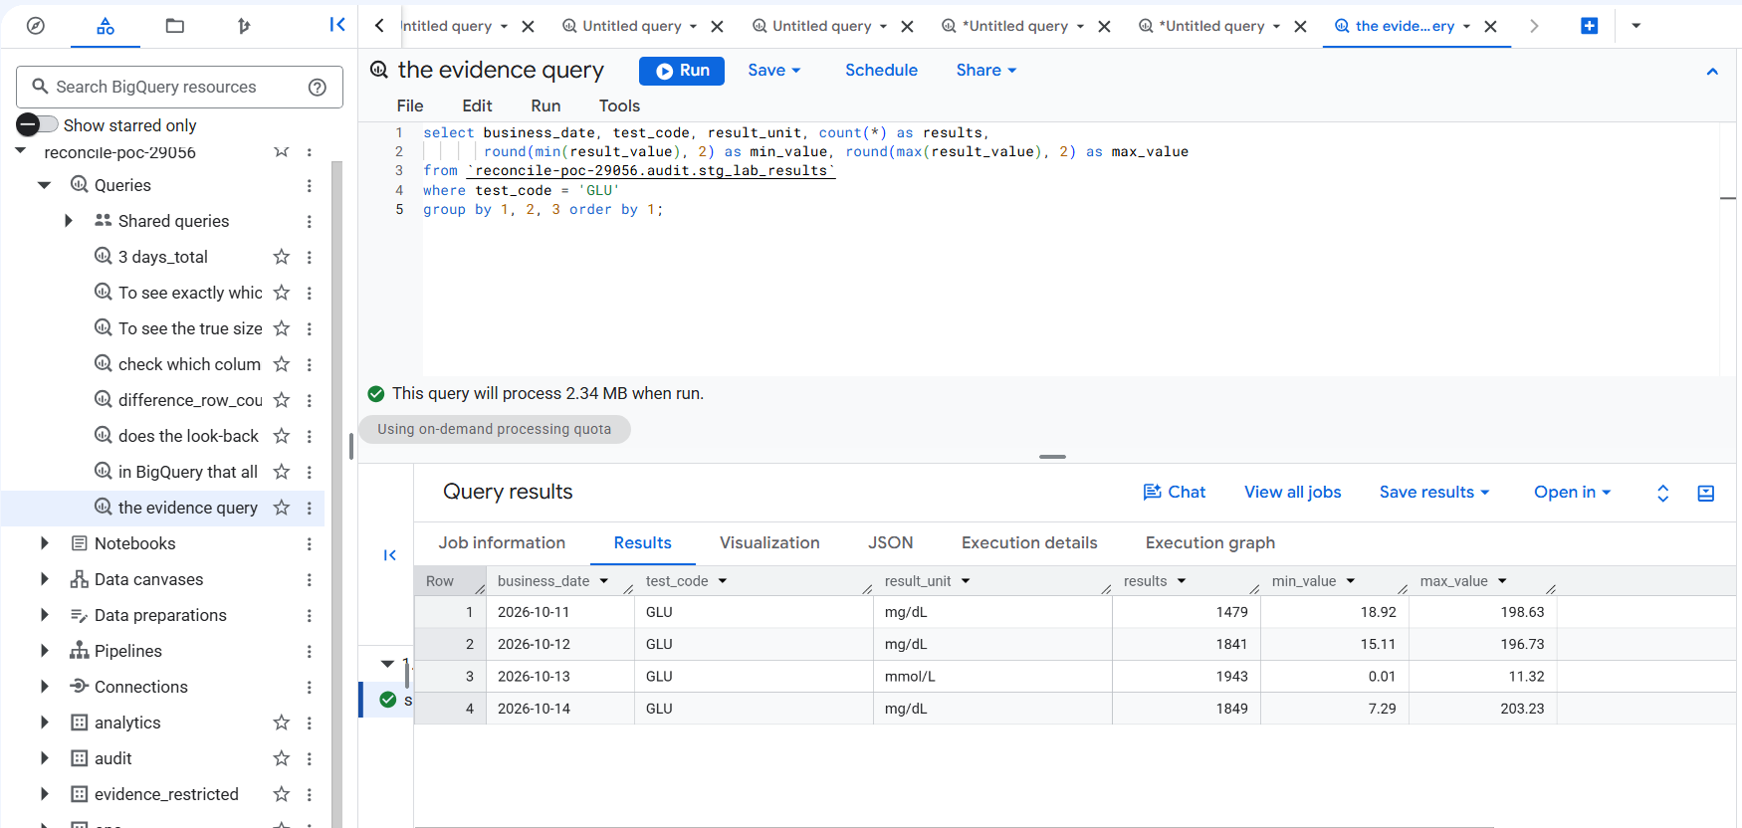
Injected: 13 Oct GLU in mmol/L (0.01–11.32) while the other days are mg/dL (7–203)
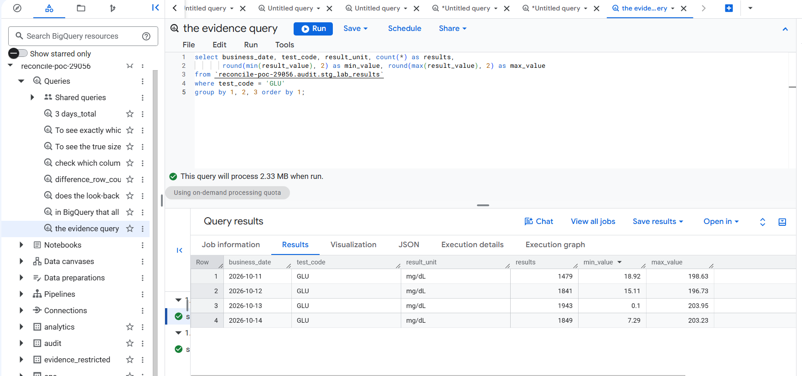
After a clean reload of 13 Oct lab results: mg/dL again; all 8 checks pass

Demo — Offsetting errors caught (T5)
docker compose exec airflow airflow dags trigger ingest_billing \
--conf '{"business_date":"2026-10-13","datasets":["claims"],"inject":["offsetting_errors"]}'
dbt build --profiles-dir . --select stg_claims+ --vars '{business_date: 2026-10-14}'
# reconcile_to_control_totals … claims FAIL 1 (unique claims and ₹ ≠ receipt)
# fct_daily_claims_matches_staging PASS (the report is faithful to staging; the receipt flags the day)

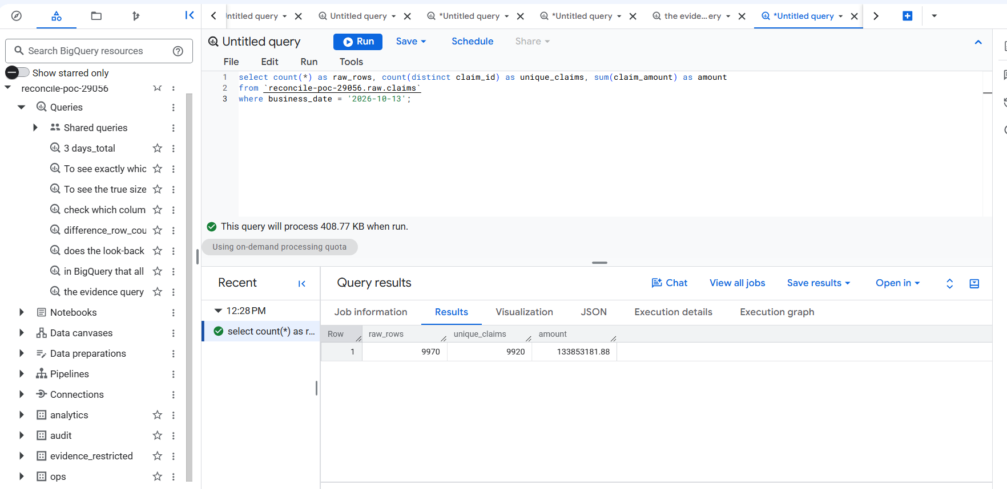
raw.claims 13 Oct: 9,970 rows (same as the receipt) but only 9,920 unique claims — 50 lost, hidden by 50 duplicates
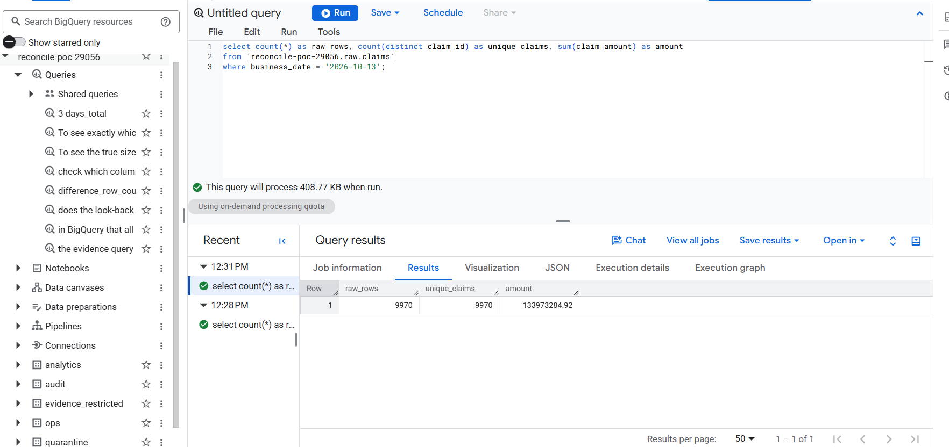
After a clean reload: 9,970 rows = 9,970 unique; ₹133,973,284.92 matches the daily claims report
Result: This is why the receipt holds three numbers, not one: the row count alone said "fine".

Demo — Duplicate rows (T4): a warning, not a block
docker compose exec airflow airflow dags trigger ingest_billing \
--conf '{"business_date":"2026-10-13","datasets":["claims"],"inject":["duplicate_rows"]}'
dbt build --profiles-dir . --select stg_claims+ raw_claims_no_duplicates --vars '{business_date: 2026-10-14}'
# raw_claims_no_duplicates WARN 12 · everything else PASS · Done. PASS=12 WARN=1 ERROR=0

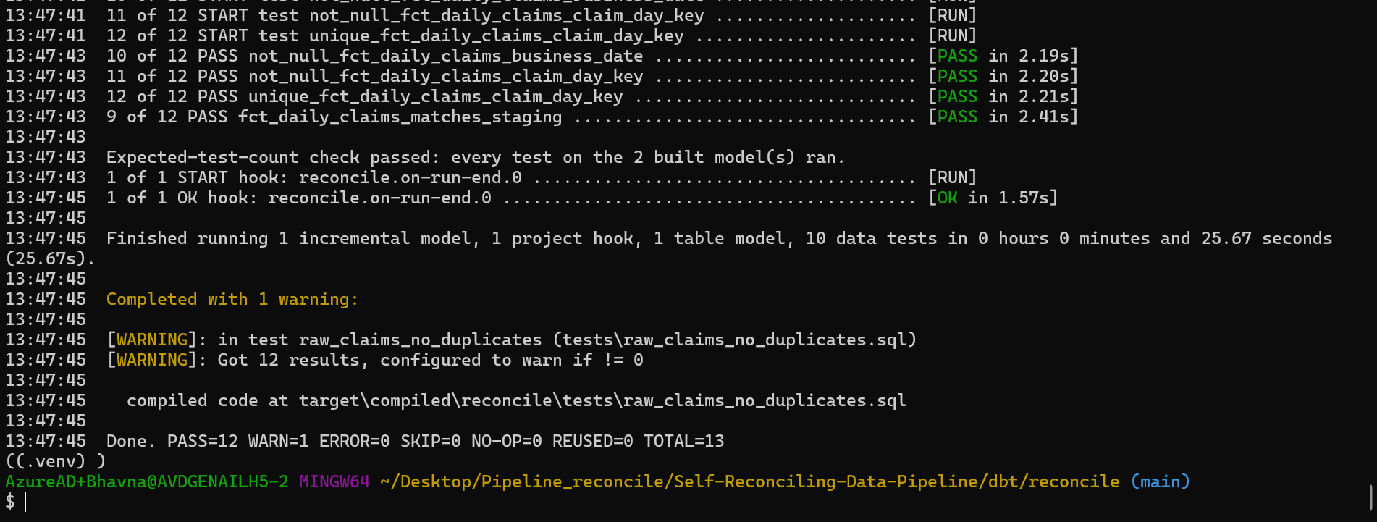
Retried batch: 12 claims twice in raw → warning; staging removes the copies, so the receipt still matches

Step 11 — Value-level reconciliation with KMS (T6)
Counts, IDs, units and ranges can all pass while values are wrong — e.g. a code change that rounds 14 results. The value check compares every critical field between raw and staging without exposing values:
- Each result_value, result_unit and collected_at is turned into a canonical text and then an encrypted fingerprint with BigQuery deterministic encryption (same value → same fingerprint).
- The encryption key is a keyset wrapped by Cloud KMS (reconcile/recon-digest, asia-south1); only sa-valuerecon may use the KMS key.
- Where raw and staging fingerprints differ, a row goes to evidence_restricted.value_recon_lab_results with record key and field name only — never values or fingerprints.
- Each run replaces its 3-day window, so a repaired day leaves no stale evidence.

Piece | Purpose
infra/kms.tf (+ cloudkms.googleapis.com in apis.tf) | Key ring reconcile, key recon-digest; role `roles/cloudkms.cryptoKeyEncrypterDecrypterViaDelegation` for sa-valuerecon only
infra/outputs.tf | Adds SA_VALUERECON and KMS_RECON_KEY to .env
profiles.yml target valuerecon | dbt connection impersonating sa-valuerecon
macros/create_recon_keyset.sql | One-off: wrapped keyset v1 into evidence_restricted.recon_keyset
models/value_recon/value_recon_lab_results.sql | Fingerprint comparison; enabled only on the valuerecon target; static 3-day partitions
tests/value_recon/value_recon_lab_results_clean.sql | Any difference → blocking failure
tests/value_recon/evidence_has_no_values.sql | Evidence table may only have key/field/issue/version/time columns
dbt_project.yml +schema: audit | Models stay in audit whichever connection runs them

make tf-plan && make tf-apply # KMS API, key ring, key, IAM — type "yes" (paste only this command)
make env && make down && make up # .env gains SA_VALUERECON, KMS_RECON_KEY; Airflow re-reads it
dbt debug --profiles-dir . --target valuerecon
dbt run-operation create_recon_keyset --profiles-dir . --target valuerecon # → Recon keyset v1 is ready
dbt build --profiles-dir . --target valuerecon --select tag:valuerecon --vars '{business_date: 2026-10-14}' # PASS=4

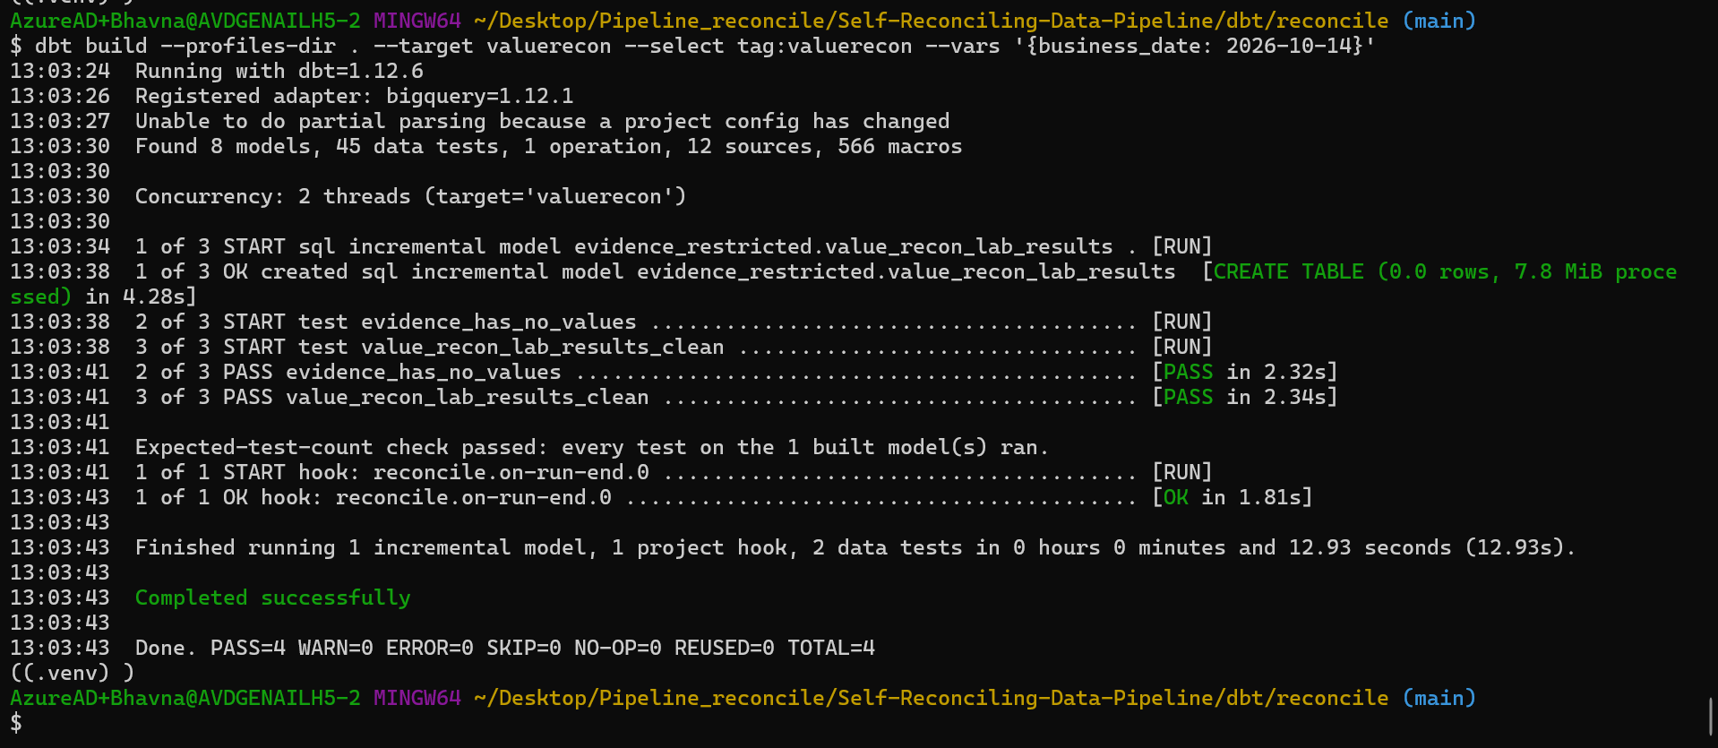
Clean data: 0 differences; evidence_has_no_values and value_recon_lab_results_clean pass
Watch: Two fixes on the way: (1) useToEncryptViaDelegation denied — BigQuery uses KMS on the caller's behalf, so the role must be …EncrypterDecrypterViaDelegation, not the plain encrypter/decrypter role. (2) "Table evidence_restricted.stg_lab_results not found" — on the valuerecon connection models defaulted to evidence_restricted; fixed with +schema: audit in dbt_project.yml. Also: Google never deletes KMS key rings; a later tf-destroy only disables the key.

Demo — Value truncation caught (T6)
# a "buggy release" rounds 14 results of 13 Oct — every check on stg_lab_results still passes (PASS=8)
dbt build --profiles-dir . --select stg_lab_results --vars '{business_date: 2026-10-13, inject_value_truncation: true}'
# the value check catches it
dbt build --profiles-dir . --target valuerecon --select tag:valuerecon --vars '{business_date: 2026-10-13}'
# value_recon_lab_results_clean FAIL 1 (13 Oct · result_value · value_differs · 14)
# evidence_has_no_values PASS
# repair: rebuild without the switch, re-check → PASS; evidence for 13 Oct back to 0 rows

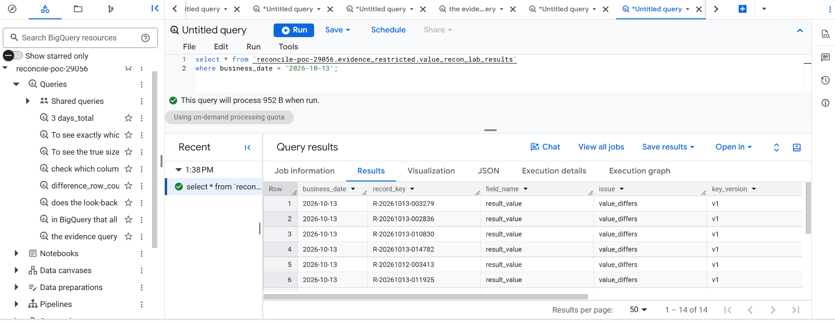
Evidence: 14 rows with record key, field name, issue and key version only — no lab values
Result: A silent value corruption that every count, ID, unit and range check missed was caught, and the evidence exposes no patient values.

Step 11h — The value check in Airflow
dbt_build now has three tasks: dbt_debug → dbt_build_and_test (as sa-dbt) → value_recon (as sa-valuerecon, --target valuerecon --select tag:valuerecon).
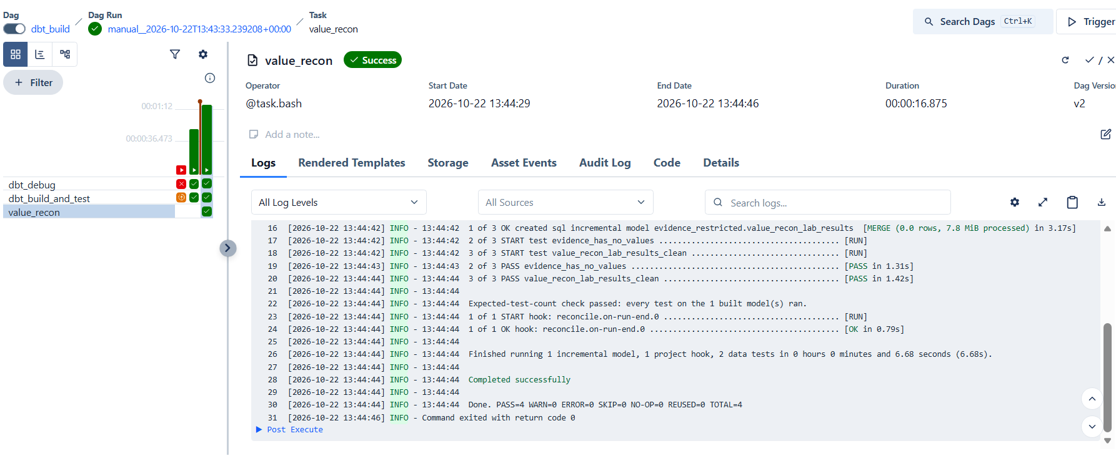
dbt_build with value_recon green: evidence_has_no_values and value_recon_lab_results_clean pass · PASS=4

Phase 2 exit gate
Exit-gate item | Injected | Caught by | Proven
Missing hour (T3) | drop_hour | receipt: rows and IDs | ✅ 21 Oct
Missing receipt (T2) | missing_control_totals | control_totals_present | ✅ 21 Oct
Raw duplicates (T4) | duplicate_rows | raw warning; staging dedupe | ✅ 22 Oct
Offsetting 50 + 50 (T5) | offsetting_errors | receipt: IDs and ₹ | ✅ 22 Oct
Unit change (T11) | unit_change | unit / range check | ✅ 22 Oct
14-row truncation (T6) | inject_value_truncation | value-level KMS check | ✅ 22 Oct
Skipped test (T7) | --exclude | expected-test-count | ✅ 22 Oct
No values in evidence | — | evidence_has_no_values | ✅ 22 Oct

Watch: A scheduled ingest run fired at 01:00 IST (21 Oct 19:30 UTC) because the ingest DAGs had been left unpaused. Switch the three ingest toggles off after every manual run (make trigger and demo triggers unpause them).

Deferred to Phase 3: the results collector, /api/reconciliation and the console Reconciliation screen — built together with the Publication screen.

7. Next — Phase 3: the publication gate
Goal: reports only ever see verified days. Each table and day is published or held.
- A publication state per table and day: PENDING → PUBLISHED, HELD, or PUBLISHED_WITH_CAVEAT (owner-approved).
- A dependency map from dbt: if encounters is held, fct_daily_claims (which joins it) is held too.
- A publish job on Cloud Run as sa-publish copies verified tables from audit to analytics (table clone), taking a snapshot first for rollback.
- Only sa-publish can write analytics — already enforced since Phase 0.
- Console: a publication ledger (tables × days) and a "Data delayed — last verified 12 Oct" banner.

Example: Encounters for 13 Oct fails reconciliation. 13 Oct encounters and fct_daily_claims stay on 12 Oct and are marked delayed; lab results and claims-only tables publish normally.

8. Query library
All queries used so far, ready to paste into BigQuery (project reconcile-poc-29056).

Receipts per day (all batches)
select business_date, count(distinct dataset) as datasets, sum(row_count) as total_rows
from `reconcile-poc-29056.ops.control_totals`
group by business_date order by business_date;

True day size (latest receipt per table)
select business_date, count(*) as datasets, sum(row_count) as total_rows
from (select * from `reconcile-poc-29056.ops.control_totals`
qualify row_number() over (partition by business_date, dataset order by extracted_at desc) = 1)
group by business_date order by business_date;

Rows per table per day
select dataset,
sum(if(business_date='2026-10-11', row_count, 0)) as oct_11,
sum(if(business_date='2026-10-12', row_count, 0)) as oct_12,
sum(if(business_date='2026-10-13', row_count, 0)) as oct_13
from (select * from `reconcile-poc-29056.ops.control_totals`
qualify row_number() over (partition by business_date, dataset order by extracted_at desc) = 1)
group by dataset order by dataset;

Receipt and money column per table
select dataset, any_value(key_column) key_column, any_value(amount_column) amount_column
from `reconcile-poc-29056.ops.control_totals` group by dataset;

Load log (latest first)
select dataset, batch_id, status, rows_extracted, rows_loaded, archive_uri, error
from `reconcile-poc-29056.ops.batches`
where business_date = '2026-10-13' order by finished_at desc;

Staging rows per day
select business_date, count(*) as encounters
from `reconcile-poc-29056.audit.stg_encounters`
group by business_date order by business_date;

Claims by status (reversals)
select business_date, status, count(*) as claims, sum(claim_amount) as amount
from `reconcile-poc-29056.audit.stg_claims`
group by business_date, status order by business_date, status;

Daily claims report (after step 6)
select business_date, sum(claims) claims, sum(reversed_claims) reversed,
sum(gross_amount) gross, sum(net_amount) net
from `reconcile-poc-29056.audit.fct_daily_claims`
group by 1 order by 1;

9. Troubleshooting
Symptom | Cause | Fix
Pasted command starts with ^[[200~ | Bracketed paste in Git Bash | bind 'set enable-bracketed-paste off'
fnm / Scoop tools "command not found" in Git Bash | Scoop shims not on PATH | Add $HOME/scoop/shims to the top of ~/.bashrc
python is the wrong version | Python 3.14 first on PATH | Create the venv with python312 -m venv .venv
CRYPT_E_REVOCATION_OFFLINE | Company network blocks revocation checks | Push from PowerShell; curl --ssl-no-revoke
tf-apply: API "has not been used… or it is disabled" | New project | Enable base APIs (4.2), wait, re-run
deploy-console: File [/tmp/…] does not exist | Git Bash temp path | Fixed in deploy_console.sh (cygpath)
Airflow tasks cannot authenticate | Compose mounted the Mac gcloud path | Set GCLOUD_CONFIG_DIR (3.4), make down && make up
Load fails: decimal target types and schema | Old warehouse.py | Fixed in commit 3e37dac
G1 shows fewer than 9 datasets | verify ran during loads | Wait for green, re-run verify
Postgres log: database "reconcile" does not exist every 5 s | Health check without -d | Harmless; optionally add -d source_replica to the health check
dbt: No dbt_project.yml found | Ran from the project root | cd dbt/reconcile
git: pathspec … did not match | Ran from dbt/reconcile | cd ../.. to the project root
BigQuery: Unexpected keyword ROWS | rows is reserved | Use another alias, e.g. total_rows
2 ingest unit tests fail locally | Windows path / firewall behaviour | Expected; they pass on Linux CI
Scheduled DAG run fails at 01:00 IST | DAGs left unpaused | Switch the toggles off after manual runs
Airflow dbt_debug: No such option '--target-path' | dbt debug has no such flag | Use DBT_TARGET_PATH / DBT_LOG_PATH env vars (Step 8)
docker compose exec airflow dbt: executable not found | dbt lives in its own venv | Use /home/airflow/dbt-venv/bin/dbt
make up takes ~20 minutes | Image rebuild downloads dbt (company network) | Only after Dockerfile changes; later starts reuse the image
dbt: "Exited because of keyboard interrupt" after a FAILED check | dbt wording for an on-run-end failure | Expected; the run did fail (check echo $?)
useToEncryptViaDelegation denied (KEYS.NEW_WRAPPED_KEYSET) | Plain KMS encrypter role | Grant roles/cloudkms.cryptoKeyEncrypterDecrypterViaDelegation
valuerecon: evidence_restricted.stg_lab_results not found | Models defaulted to the target dataset | +schema: audit under models in dbt_project.yml
Airflow DAGs "Deactivated" / Dag Import Error | A DAG file was overwritten (e.g. Dockerfile text pasted) | git checkout -- <file>; airflow dags reserialize; list-import-errors
--conf JSON error from PowerShell | PowerShell strips inner quotes | Run docker compose commands in Git Bash
tf-apply "Apply cancelled" | The next pasted line answered the yes/no prompt | Paste only make tf-apply, then type yes

10. Change log
Date | Phase | Change
20 Oct 2026 | 0 | Project reconcile-poc-29056 created; Terraform applied (119 resources); console deployed; CI green (0a08808). Windows fixes: deploy temp path (7ea0254).
21 Oct 2026 | 1 | Loaded 11–13 Oct; G1–G5 passed for each date. Fixed BigQuery load (decimal_target_types) and Airflow gcloud mount on Windows (3e37dac).
21 Oct 2026 | 2 | dbt connected as sa-dbt; stg_encounters / stg_claims / stg_lab_results; reconciliation and receipt tests; proved drop_hour (117 missing) and missing-receipt detection; proved 3-day look-back with 14 Oct reversals.
22 Oct 2026 | Doc | This runbook (v1.0) created.
22 Oct 2026 | 2 | Steps 6–8: marts (dim_encounters, fct_daily_claims, fct_bed_occupancy) + mart-vs-staging test, PASS=49; policy_outcome default and expected-test-count check (T7 proven); dbt in Airflow (own venv, mounted project, dbt_build DAG) green with PASS=49. Runbook v1.1.
22 Oct 2026 | 2 | Steps 9–12: lab unit/range check (T11), offsetting_errors + unit_change injectors (T5), duplicate demo (T4), KMS value-level reconciliation as sa-valuerecon with evidence holding keys only (T6), value_recon task in Airflow. Phase 2 exit gate passed. Runbook v1.2.

